**Commands OF MYSQL**

SQL is not case-sensitive we can write command either capital or either small letter.

^C is used to return to command.

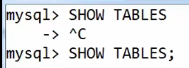

**To start server**

* **mysqld –console**
* **cd\**
* **mysql/bin**
* **mysql -u root -p**
* **Enter password: \*\*\*\*\*\*\*\***

1. **CREATE DATABASE**- Used to create database.

Syntax - create database database_name;

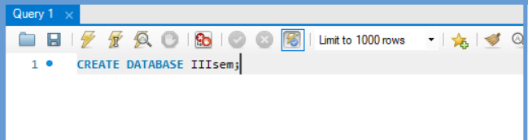

1. **USE** - For particular use of database.

Syntax - use database_name;

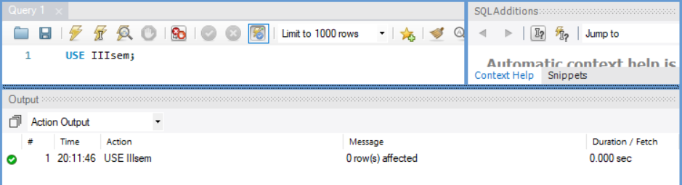

1. **Create Table**- To create table

Syntax- CREATE TABLE table_name(

Column_name1 data_type(size) [constraints],

Column_name2 data_type(size)[constraints],

Column_name3 data_type(size) [constraints]

);

Ex - CREATE TABLE my_tab(

name varchar(30) NOT NULL,

roll number (4) PRIMARY KEY,

address (100)

);

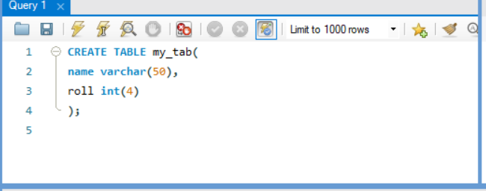

**NOTE**- VARCHAR hold string

**Rules** to create table :)

1. Table name should start with alphabet.
2. Reserved words of that RDMS/DBMS cannot be used as table name.
3. Proper data type and size should be specified.
4. Unique column name should be specified (duplicate column name are not allowed in same database).
5. **DESC** - This is used to describe table. It describes structure (like datatype, null or not, constraint, primary key etc) of table not information (row) inside table. DESC is short form of **describe**.

Syntax – DESC table_name;

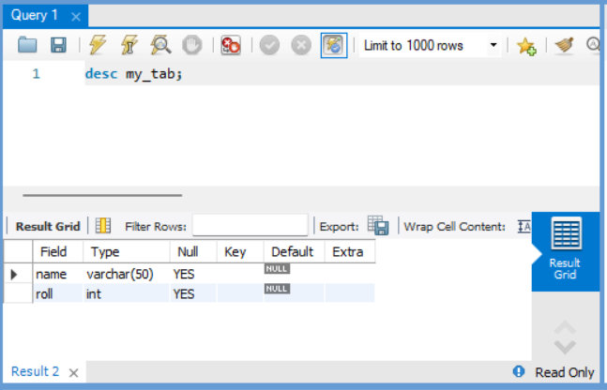

1. **SHOW** **DATABASE** – This command is used to view all the databases name.

Syntax – SHOW DATABASES;

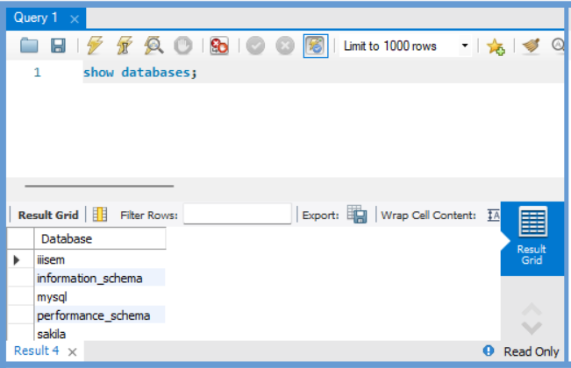

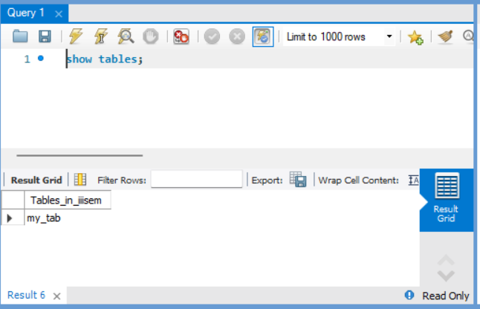

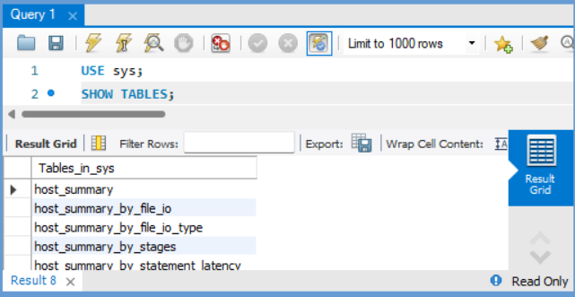

**DATA TYPES**

Mysql uses many different data types broken into three categories –

1. Numeric
2. Date and time
3. String Type
4. Numeric data types –

|  |  |  |  |
| --- | --- | --- | --- |
| Numeric | Signed | Unsigned | Width |
| Int | -2147483648 to 2147483647 | 0 to 4294967295 | 11 digits |
| Tinyint | -128 to 127 | 0 to 255 | 4 digits |
| Smallint | -32768 to 32767 | 0 to 65535 | 5 digits |
| Mediumint | -8388608 to 8388607 | 0 to 16777215 | 9 digits |
| Bigint | -9223372036854775808 to 9223372036854775807 | 0 to 18446744073709551615 | 20 digits |
| Float (M, D)  M – Total size (including decimal)  D - Decimal | No | floating-point number that cannot be unsigned | Default= (10, 2)  Decimal = 24 |
| Double (M, D)  M – Total size (including decimal)  D – Decimal  (also known as REAL) | No | double precision floating-point number that cannot be unsigned | Default = (16, 4)  Decimal = 53 |
| Decimal (M, D)  (also known as NUMERIC) | No | An unpacked floating-point number that cannot be unsigned | Decimal range = 0 to 30 |

1. Date and Time Type –

|  |  |  |  |
| --- | --- | --- | --- |
| Date and Time | Format | Between | Example |
| Date | YYYY-MM-DD | 1000-01-01 And 9999-12-31 | 1973-12-30 |
| DateTime  8 -byte | YYYY-MM-DD HH:MM:SS | 1000-01-01 00:00:00  And 9999-12-31 23:59:59 | 1973-12-30 15:30:00 |
| TimeStamp  4 -byte | YYYY-MM-DD HH:MM:SS | '1970-01-01 00:00:01' UTC to '2038-01-19 03:14:07' UTC. | 19731230153000 ( YYYYMMDDHHMMSS ). |
| Time | HH:MM:SS | No | 15:10:38 |
| Year (M)  2, 4 digit format | YEAR(M) | 1970 to 2069 (70 to 69)  specified as 4, then YEAR can be 1901 to 2155 | Default = 4 |

1. String Types

|  |  |  |
| --- | --- | --- |
| String Type | Between | Default |
| Char(M) | 1 and 255 characters | Defining length is not required (1) |
| Varchar(M) | 1 and 255 characters with numeric | Must define length |
| Blob or Text  Non case sensitive or Case sensitive | Maximum length 65535 character | Do not specify a length with blob and text. |
| TinyBlob or Tinytext | Maximum length 255 character | Do not specify a length with Tinyblob and Tinytext. |
| MediumBlob or MediumText | Maximum length 16777215 | Do not specify a length with MediumBlob and MediumText. |
| LongBlob or LongText | Maximum length 4294967295 character | Do not specify a length with LongBlob and LongText. |

* 1. **INT or INTEGER** –
     1. it holds whole number between -32,768 to 32767 either it is -ve or +ve.
     2. It cannot hold a decimal number.
     3. The maximum number of digits may be specified in parenthesis ().

Syntax – column_name INT (size);

* 1. **DEC or DECIMAL (size, p)** –
     1. Its holds fixed point numbers.
     2. Size is the total number of digits (size = 4 ex: - 1234) and p is the number of points after the decimal point (p=2 ex: - 12.34).
     3. The decimal point and the negative sign ‘- ‘ are not counted in size.
     4. If p is 0, values have no decimal point (size = 4, p=0 ex- 1234).
     5. The maximum number of sizes for decimal is 65 and for p is30.
     6. If p is omitted the default is 0, if size is omitted the default is 10.

Syntax- column_name DECIMAL (4, 2);

* 1. **CHAR or CHARACTER** –
     1. It holds a fixed length string (can contain letters, numbers, and special characters).
     2. The fixed size is specified in parenthesis ().
     3. It can store up to 255 characters.

Syntax – column_name CHAR (20);

* 1. **VARCHAR** –
     1. It holds a variable length string (can contain letters, numbers, and special characters).
     2. The maximum size is specified in parenthesis ().
     3. It can store up to 255 characters.

**NOTE** – If we put a greater value than 255 it will be converted to a TEXT type.

Syntax – column_name VARCHAR (size);

* 1. **TEXT** –
     1. It holds a string with a maximum length of 65,535 characters.

Syntax– column_name TEXT;

* 1. **DATE –** 
     1. It displays in yyyy-mm-dd.

Syntax – column_name DATE;

* 1. **DATETIME** –
     1. It displays DATETIME value in yyyy-mm-dd hh:mm:ss format.

Syntax – column_name DATETIME;

* 1. **TIMESTAMP** –
     1. It also displays data and time.

Syntax – column_name TIMESTAMP;

**EXAMPLE OF ALL DATATYPES**

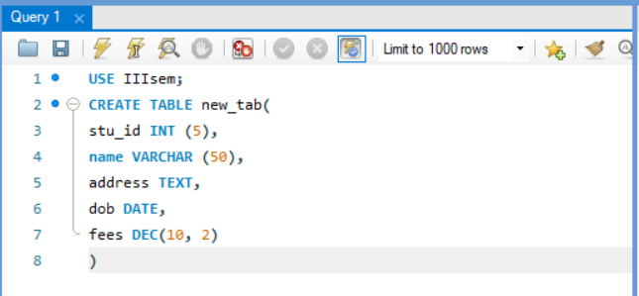

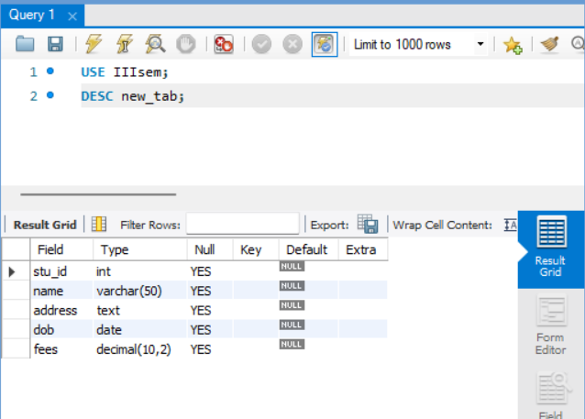

**HELP AND SUPPORT –**

Commands :-

1. help contents –

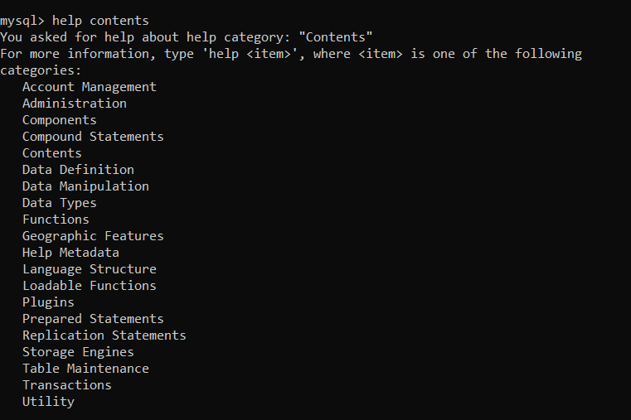

1. help data manipulation –

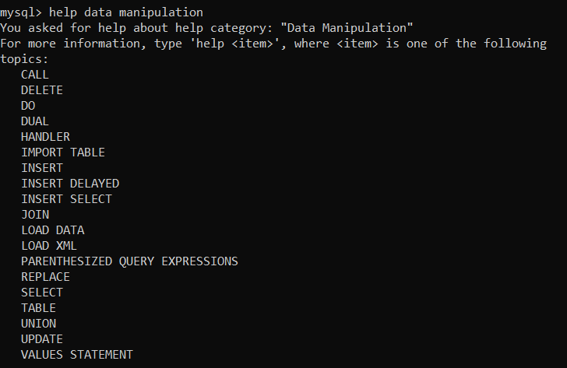

1. help data definition –

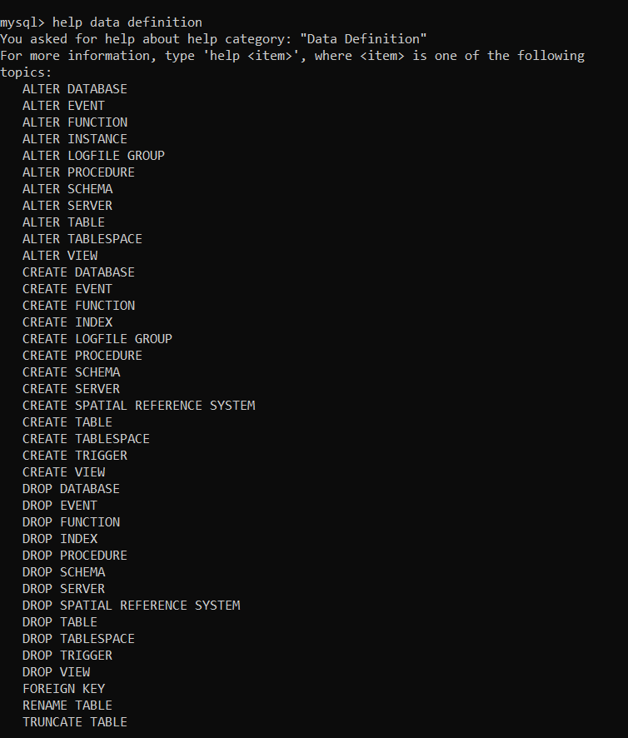

**INSERT INTO –**

**With specifying columns name.**

* The insert into statement is used to insert new column/row/tuple in a table.
* No semicolon at the end of INSERT INTO.
* In VALUES semicolon are optional.

Syntax –

INSERT INTO table_name (column1, column2, column3….)

VALUES (value1, ‘value2’, ‘value3’, value4…..)

**RULES** –

1. Column and Value order should be same.
2. Any values that go into a VARCHAR, CHAR, DATE or TEXT column has single quotes around it. There is no need of quotes for numeric values (INT, DEC)

NEED SINGLE QUOTES –

* CHAR
* VARCHAR
* DATE
* DATETIME
* TIMESTAMP
* TIME
* BLOB
* TEXT

NO NEED SINGLE QUOTES –

* INT or INTEGER
* DEC or DECIMAL

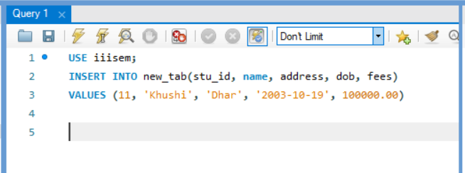

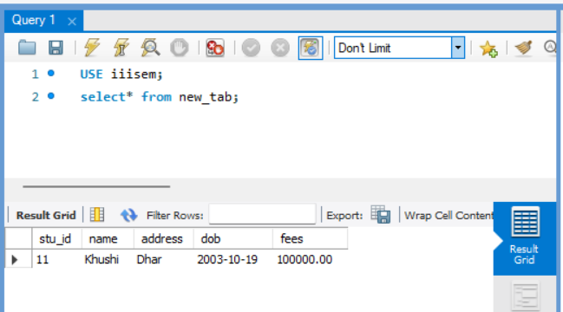

**Without specifying columns name**

Syntax –

INSERT INTO table_name

VALUES (value1, ‘value2’, ‘value3’, value4….);

**RULES** –

1. The values order should be same as column.
2. We need to insert record froe ac column we cannot leave any column.

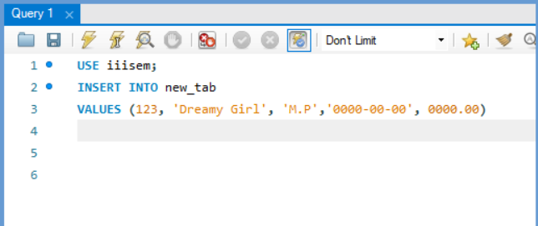

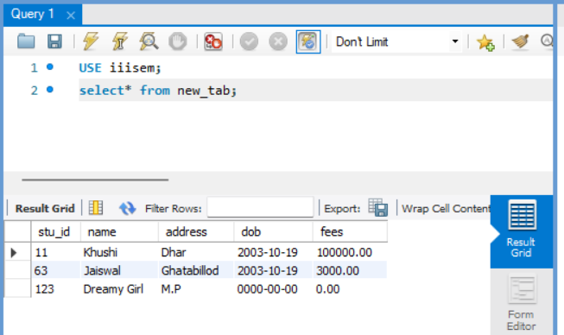

**NOTE** –

If we skip the once column



Then we show that type of error in sql.

**Changing the order of columns** –

Syntax –

INSERT INTO table_name (column2, column1, column4, column3)

VALUES (‘value2’, value1, value4, ‘value3’);

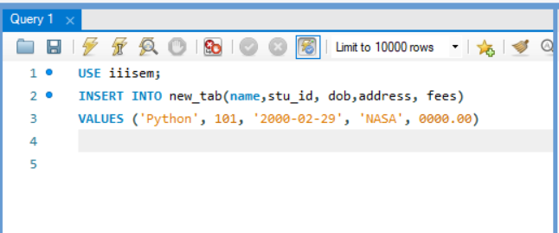

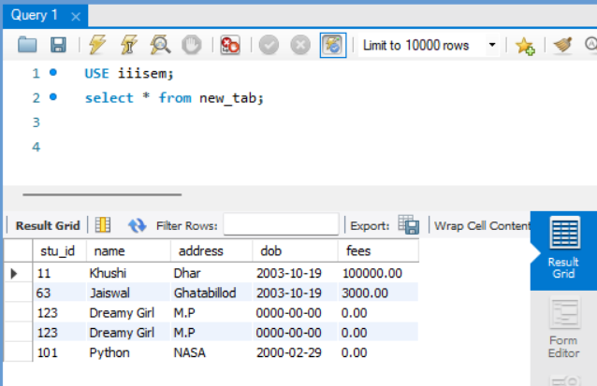

**INSERT DATA ONLY IN SPECIFIED COLUMN –**

Syntax –

INSERT INTO table_name (column1, column2, column3)

VALUES (value1, ‘value2’, ‘value3’)

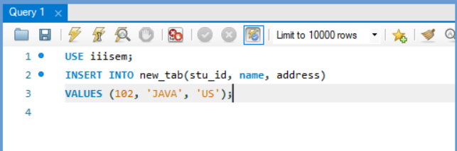

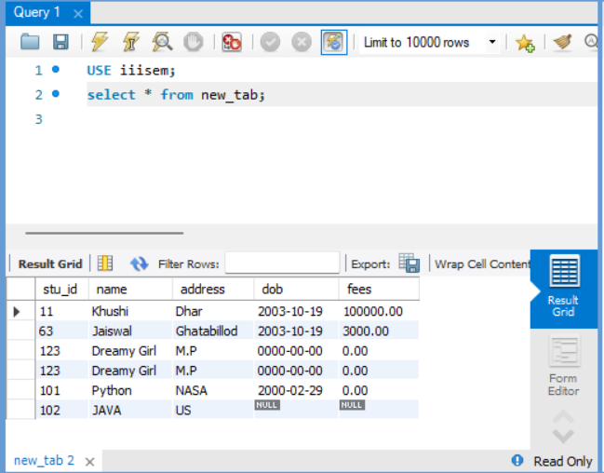

**NOTE –**

If we cannot write some column name in INSERT INTO and VALUES in this case

the table that column are shows **NULL** as shown above fig.

**INSERT MULPTIPLE RECORD AT ONE TIME –**

Syntax –

INSERT INTO table_name (column1, column2, column3, column4)

VALUES (value1, ‘value2’, ‘value3’, value4), (value1, ‘value2’, ‘value3’, value4);

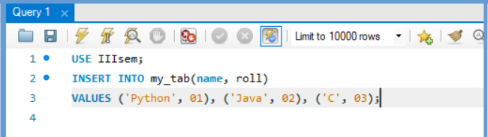



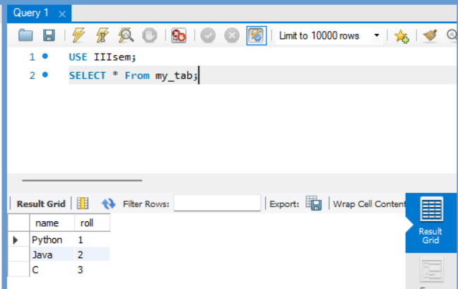

**SELECT –**

The SELECT statement is used to select data from a database and retrieve (display) the information.

* **Select all columns from the table –**

Syntax – SELECT * FROM table_name;

* **Select Particular columns from the table –**

Syntax –

SELECT column_name1, column_name2, ….

FROM table_name;

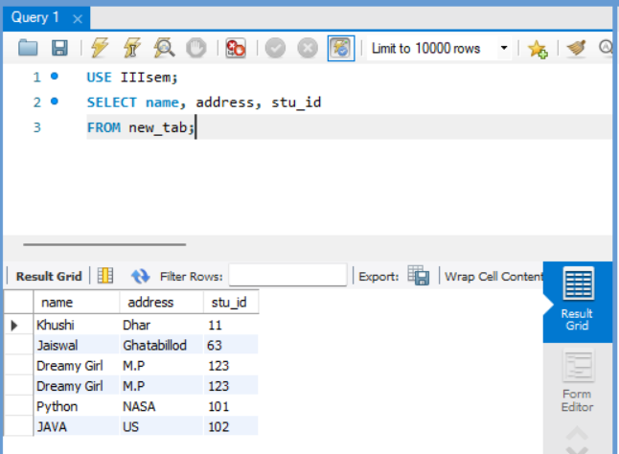

**NOTE** –

Whatever order we write in SELECT command we retrieve data in that particular order.

**SINGLE QUOTES PROBLEM –**

Ex - (‘We’ll try’)

It creates confusion for software.

There are two way to solve this problem:-

1. Use backslash

Ex:- ‘We\’ll try’

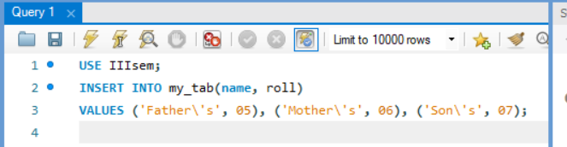

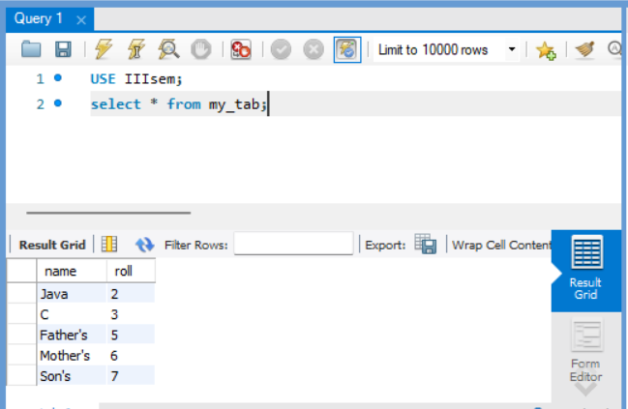

1. Use two-time single quotes

Ex: - ‘We’’ll try’

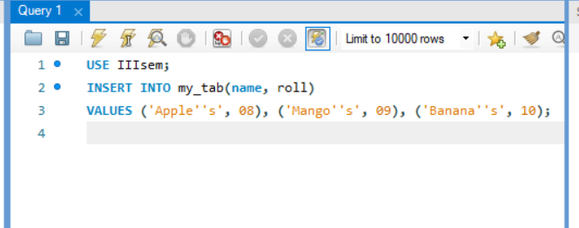

**SELECT with LIMIT –**

The SELECT LIMIT is used to specify some number of records to displays (tuples).

Syntax –

SELECT * FROM table_name

or

SELECT column_name1, column_name2

FROM table_name

LIMIT records_number;

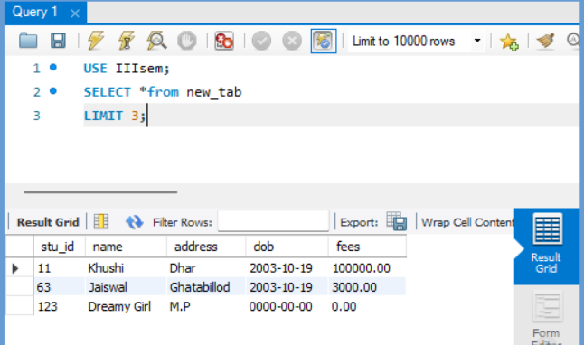

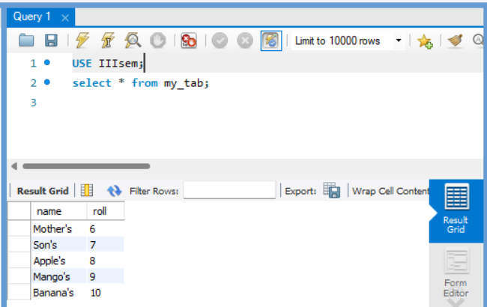

**NOTE –**

It counts the data from 0.

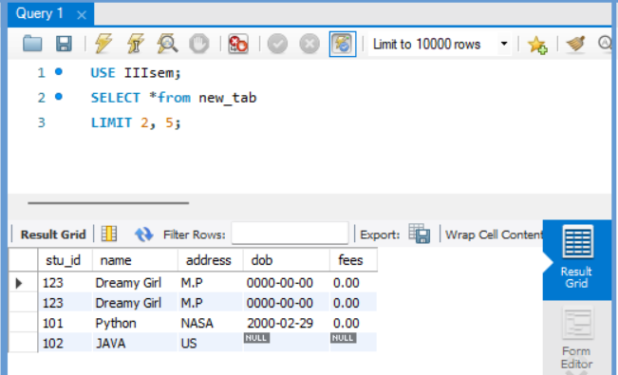

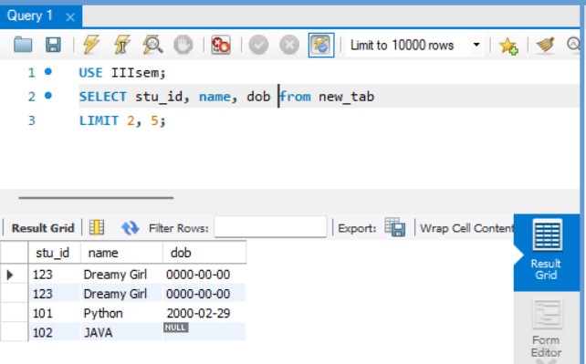

**WHERE clause –**

WHERE is used to search for a specific data.

1. **Specific data from all column –**

Syntax –

SELECT* FROM table_name

WHERE column_name operator ‘value’;

1. **Specific data from specific column –**

Syntax –

SELECT column_name FROM table_name

WHERE column_name operator ‘value’;

**NOTE –**

Value can be text or numeric. If it is text then we have to put single quotes.

|  |  |
| --- | --- |
| Operator | Description |
| = | Equal |
| < > or != | Not equal |
| > | Greater than |
| < | Less than |
| >= | Greater than or equal |
| <= | Less than or equal |
| BETWEEN | Between an inclusive range |
| LIKE | Search for a pattern |
| IN | To specify multiple possible values for a column |

Use EQUAL operator in WHERE –

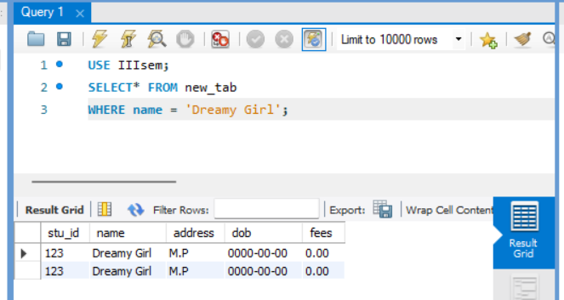

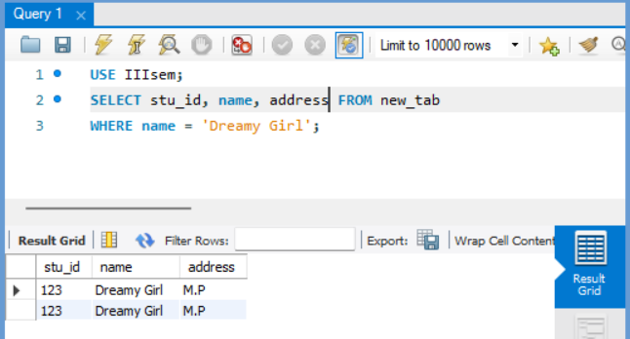

Use NOT EQUAL in WHERE –

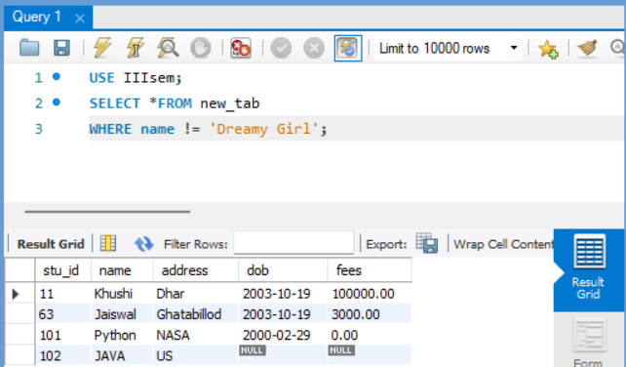

Use Greater than in WHERE –

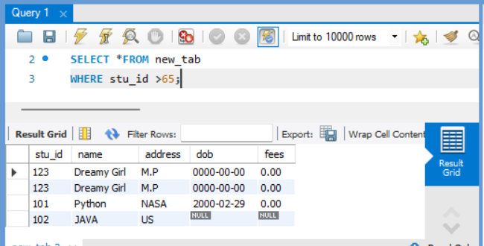

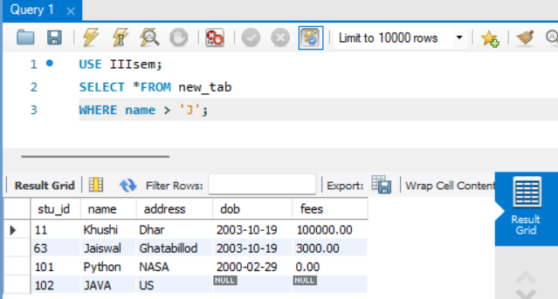

**NOTE –**

If we give some character with operator. In SQL they count that particular character or words which start from that character then it will perform that operator then give result.

Use Less than in WHERE –

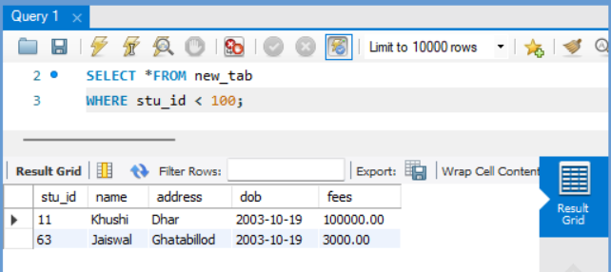

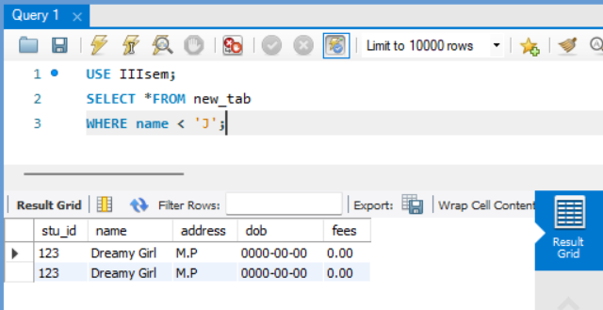

**NOTE –**

In this operator it skips that character and words.

Use Greater than equal in WHERE –

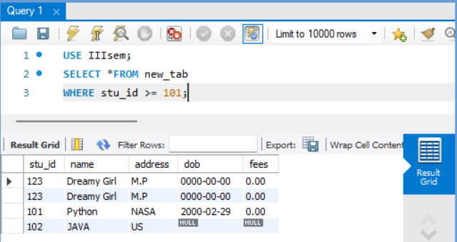

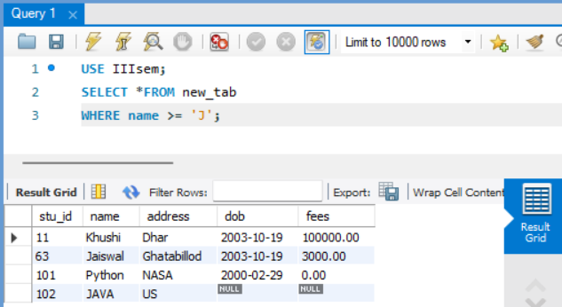

Use Less than equal in WHERE –

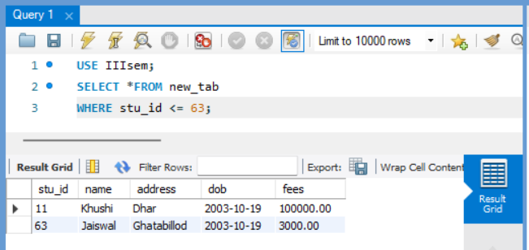

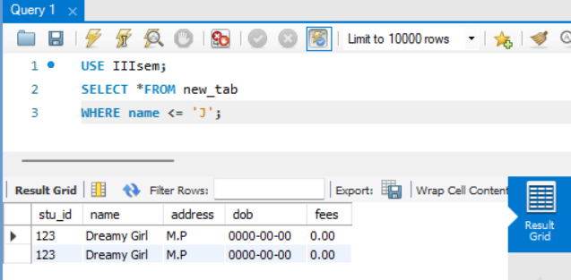

NULL –

* NULL values represent missing unknown data.
* NULL ≠ 0

1. **IS NULL –**

This is used to select only the records with NULL values in the column.

Syntax –

SELECT column_name FROM table_name

WHERE column_name IS NULL;

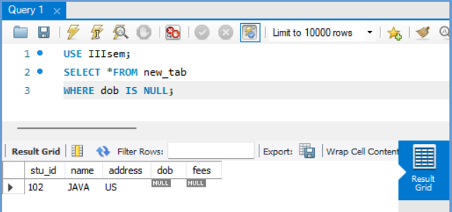

1. **IS NOT NULL –**

This is used to select only the records with no NULL values in column.

Syntax –

SELECT column_name FROM table_name

WHERE column_name IS NOT NULL;

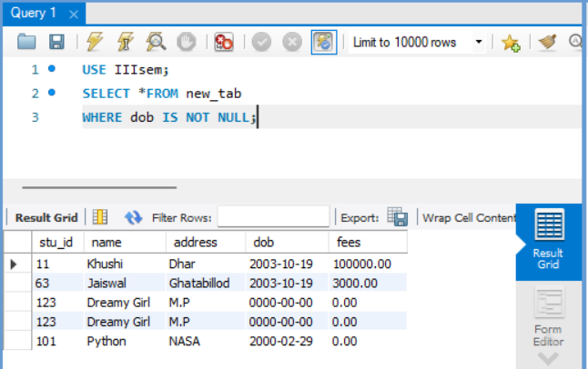

AND operator –

The AND operator displays a record if both the first condition AND the second condition are true.

Syntax –

SELECT * FROM table_name

WHERE column_name = ‘value’

AND column_name = ‘value’;

If both conditions are true.

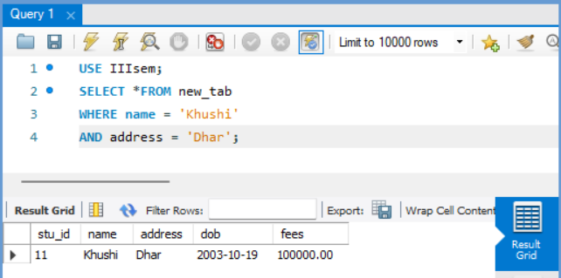

If conditions are not True.

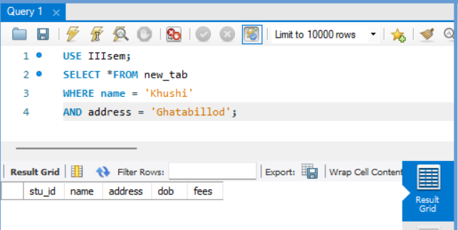

OR operator –

The OR operator displays a record if either the first condition OR second condition is true.

Syntax –

SELECT * FROM table_name

WHERE column_name = ‘value’

OR column_name = ‘value’

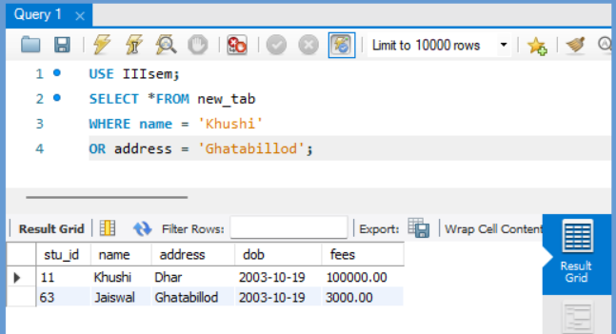

Combination of AND & OR –

Syntax –

SELECT * FROM table_name

WHERE column_name = ‘value’

AND (column_name = ‘value’ OR column_name1 = ‘value’);

Truth table of AND – OR

|  |  |  |  |  |
| --- | --- | --- | --- | --- |
| 1st  AND | 2nd (I) | 2nd (II) | 2nd (F)  I OR II | Result  AND & OR |
| T | T | T | T | T |
| T | T | F | T | T |
| F | F | T | T | F |
| F | F | F | F | F |

|  |  |  |
| --- | --- | --- |
| T | T | T |
| T | F | T |
| F | T | T |
| F | F | F |

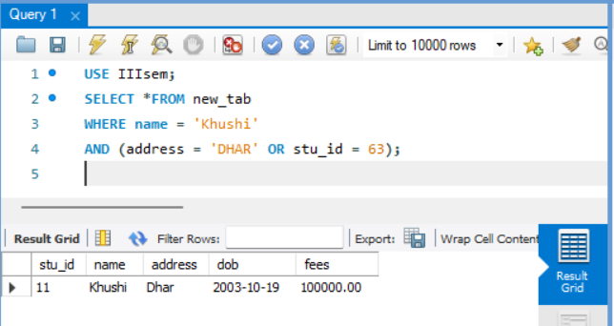

Combination of OR & OR –

Syntax –

SELECT * FROM table_name

WHERE column_name = ‘value’

OR (column_name = ‘value’ OR column_name1 = ‘value’);

Truth Table –

|  |  |  |  |  |
| --- | --- | --- | --- | --- |
| 1st  OR | 2nd (I) | 2nd (II) | 2nd (F)  I OR II | Result  OR & OR |
| T | T | T | T | T |
| T | T | F | T | T |
| F | F | T | T | T |
| F | F | F | F | F |

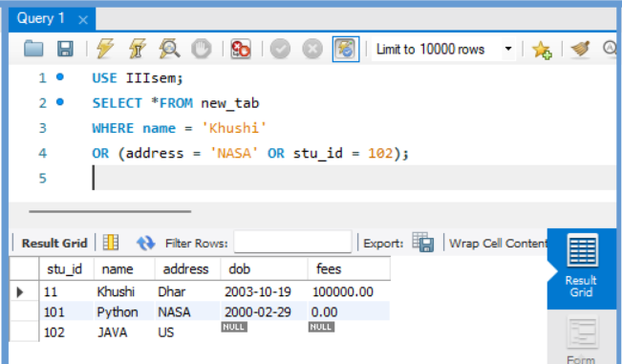

Combination of AND & AND –

Syntax –

SELECT * FROM table_name

WHERE column_name = ‘value’

AND (column_name = ‘value’ AND column_name1 = ‘value’);

Truth Table –

|  |  |  |  |  |
| --- | --- | --- | --- | --- |
| 1st  AND | 2nd (I) | 2nd (II) | 2nd (F)  I AND II | Result  AND & AND |
| T | T | T | T | T |
| T | T | F | F | F |
| F | F | T | F | F |
| F | F | F | F | F |

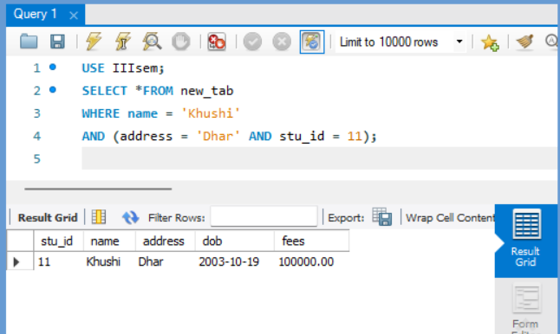

Combination of OR & AND –

Syntax –

SELECT * FROM table_name

WHERE column_name = ‘value’

OR (column_name = ‘value’ AND column_name1 = ‘value’);

|  |  |  |  |  |
| --- | --- | --- | --- | --- |
| 1st  OR | 2nd (I) | 2nd (II) | 2nd (F)  I AND II | Result  OR & AND |
| T | T | T | T | T |
| T | T | F | F | T |
| F | F | T | F | F |
| F | F | F | F | F |

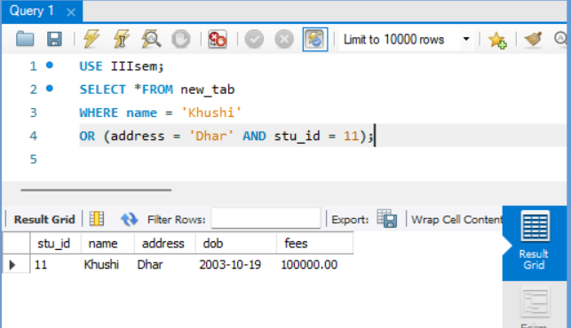

IN operator –

The IN operator allows you to specify multiple values in a WHERE clause.

Syntax –

SELECT * FROM table_name

WHERE column_name IN (‘value1’, ‘value2’, ……);

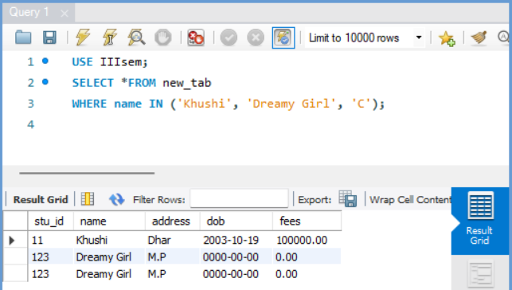

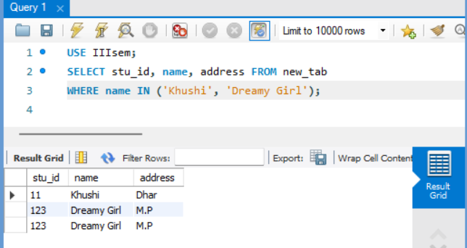

NOT IN operator –

Just opposite to IN operator.

Syntax –

SELECT * FROM table_name

WHERE column_name NOT IN (‘value1’, ‘value2’, ……….);

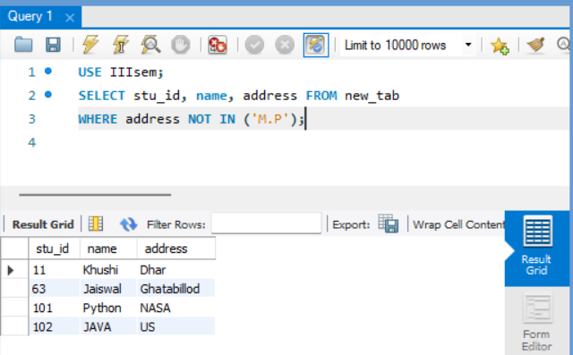

BETWEEN –

The BETWEEN operator selects values within a range. The values can be numbers, text, or dates.

* BETWEEN Number –

Syntax –

SELECT * FROM table_name

WHERE column_name BETWEEN value1 AND value2;

**BETWEEN number include value1 and value2 (Depend on RDBMS).**

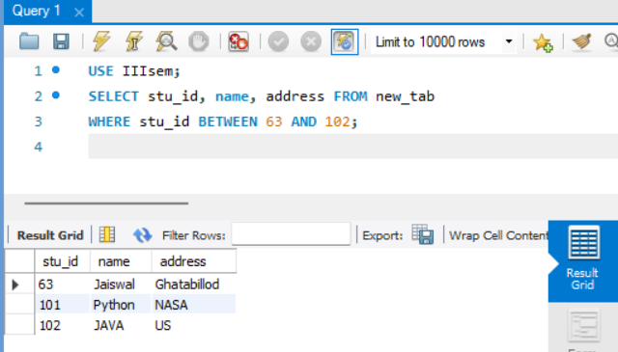

* BETWEEN TEXT –

Syntax –

SELECT * FROM table_name

WHERE column_name BETWEEN ‘value1’ AND ‘value2’;

**BETWEEN TEXT include value1 but not include value2 (Depend on RDBMS).**

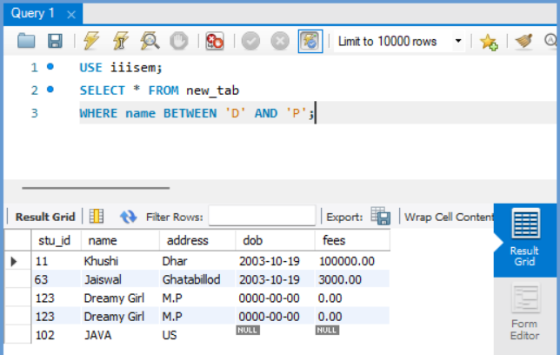

* BETWEEN DATE –

Syntax –

SELECT * FROM table_name

WHERE column_name BETWEEN ‘yyyy-mm-dd’ AND ‘yyyy-mm-dd’;

**BETWEEN DATE include both value1 and value2 (Depend on RDBMS).**

**Format of date must be same and write the values in single quotes.**

**We use -, / between the year months and date (yyyy-mm-dd and yyyy/mm/dd)**

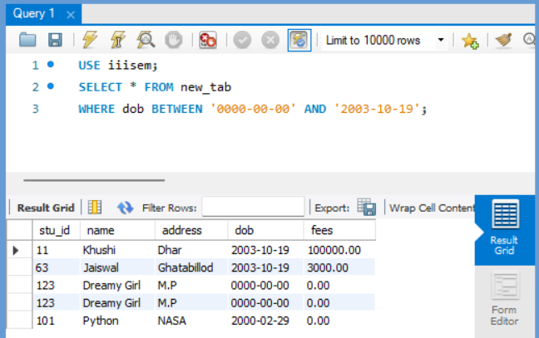

* BETWEEN WITH IN–

Syntax –

SELECT * FROM table_name

WHERE (column_name BETWEEN valule1 AND value2)

AND column_name IN (value1, value2);

**BETWEEN IN include both value1 and value2 (Depend on RDBMS).**

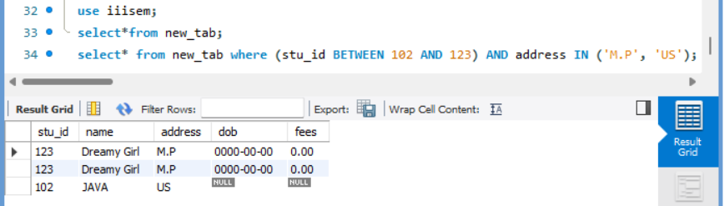

* BETWEEN with NOT IN –

Syntax –

SELECT * FROM table_name

WHERE (column_name BETWEEN value1 AND value2)

AND NOT column_name IN (value1, value2);

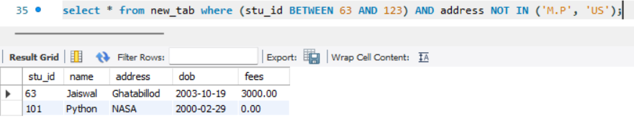

NOT BETWEEN –

To display the data which is not in the range.

* NOT BETWEEN number –

Syntax –

SELECT * FROM table_name

WHERE column_name NOT BETWEEN value1 AND value2;

**NOT BETWEEN number not include value1 and value2 (Depend on RDBMS).**

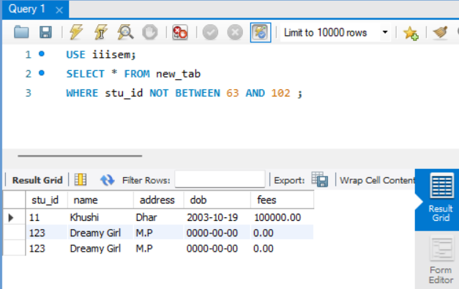

* NOT BETWEEN TEXT –

Syntax –

SELECT * FROM table_name

WHERE column_name NOT BETWEEN ‘value1’ AND ‘value2’;

**NOT BETWEEN text include value1 but include value2 (Depend on RDBMS).**

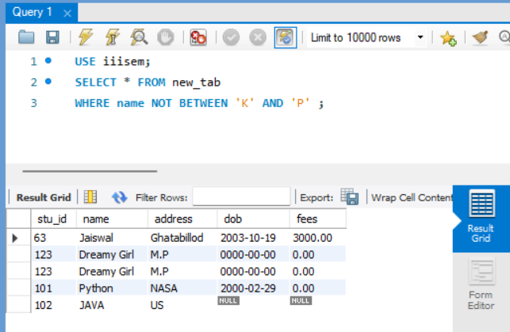

* NOT BETWEEN DATE –

Syntax –

SELECT * FROM table_name

WHERE column_name NOT BETWEEN ‘yyyy/mm/dd’ AND ‘yyyy/mm/dd;

**NOT BETWEEN DATE include value1 and value2 (Depend on RDBMS).**

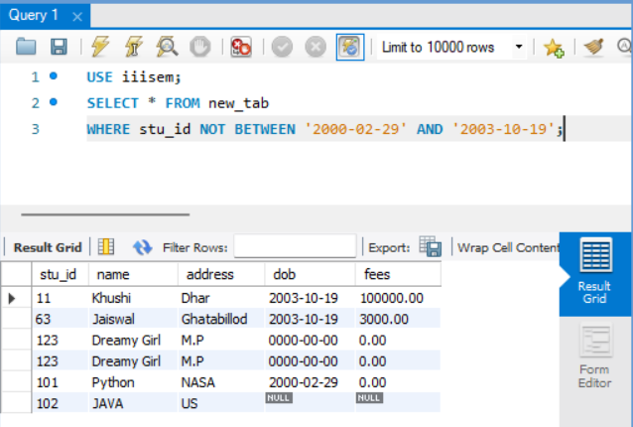

LIKE –

The LIKE operator is used to search for the specified pattern in a column.

Syntax –

SELECT* FROM table_name WHERE column_name LIKE ‘pattern’;

WILDCARDS –

Wildcards are used to search data within a table. These characters are used with the LIKE operator.

|  |  |
| --- | --- |
| Wildcard | Description |
| % | Zero or more character |
| _ | One single character |
| [charlist] | Sets and ranges of characters to match |
| [^charlist] or [! charlist] | Matches only a character NOT specified within the brackets |

1. % - Zero or more characters

‘Geeks%’ – All starting with geek. Ex: – Geekyshows

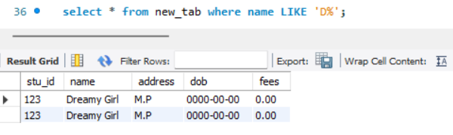

‘%shows’ – All ending with shows. Ex: - Geekyshows

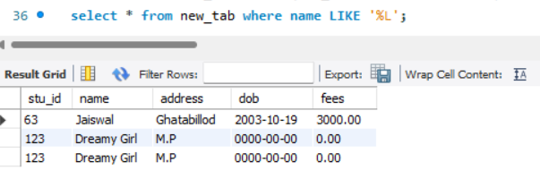

‘%sh%’ – All containing with sh. Ex: - Geekyshows

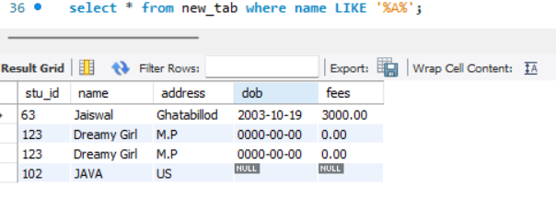

1. – One Single character –

‘Show_’ – Starting with show then only any and one character. Ex: - shows

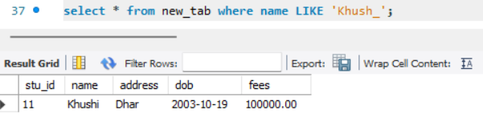

‘_eek’ – Any character with eek. Ex: - geek

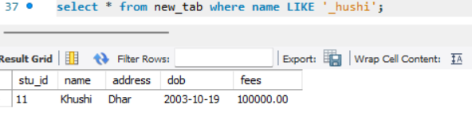

‘G_e_k’ – G then any charcter, then e any character, then k. Ex: - Geek

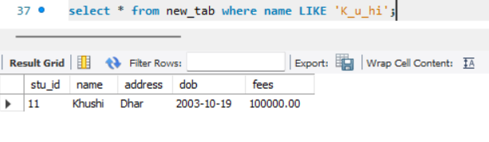

1. Like with [charlist] Wildcard –

NOTE – Does not supports in mysql.

1. Like with [^charlist] or [! charlist] Wildcard –

NOTE – Does not support in mysql

NOT LIKE

Syntax –

SELECT * FROM table_name

WHERE column_name NOT LIKE ‘pattern’;

1. % - Zero or more characters

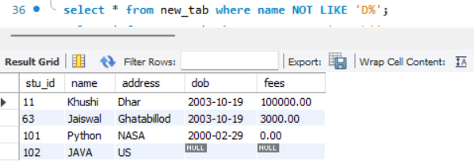

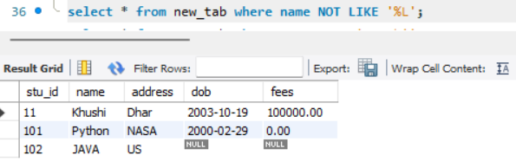

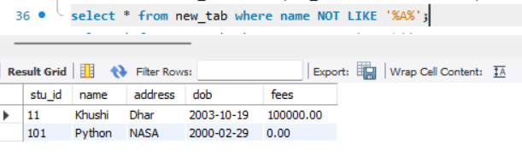

1. – One Single character –

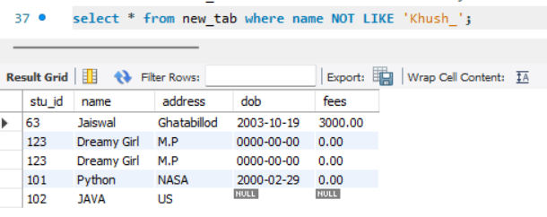

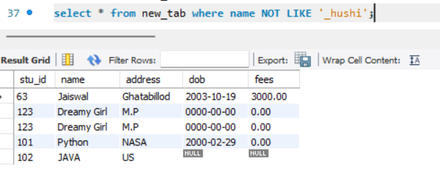

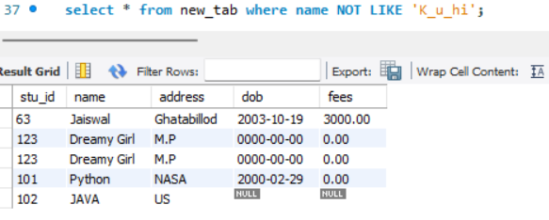

ORDER BY –

This is used to sort the records.

ASC – It sorts in ascending order (by default).

DESC – It sorts in descending order.

1. Sort the descending order –

Syntax –

SELECT * FROM table_name

ORDER BY column_name DESC;

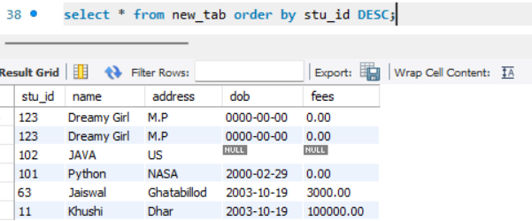

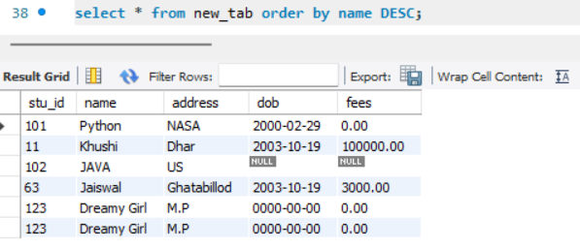

1. Sort in ascending order –

Syntax –

SELECT * FROM table_name

ORDER BY column_name ASC;

NOTE – ASC is optional.

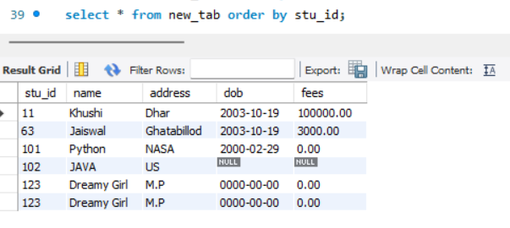

KEY CONSTRAINS –

* NOT NULL –

By default, a table’s column can hold NULL values.

The NOT NULL constraint enforces a field to always contain a value. This means that you cannot insert a new record, or update a record without adding the value to this field or attribute.

Ex: -

CREATE TABLE student (Name VARCHAR (30),

Roll INTEGER (5), Mobile_no integer (10) NOT NULL);

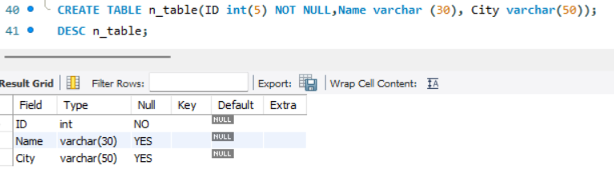

ERROR –



* 1. UNIQUE KEY –

The UNIQUE KEY constraint uniquely identifies each record in a database table.

There can be many UNIQUE constraints per table. A unique key column can contain NULL values.

Ex –

CREATE TABLE student (Name varchar (30),

Roll int (5) UNIQUE KEY, Mobile_no (10));

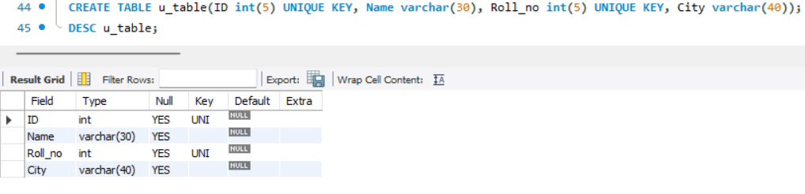

**NOTE – It contain null also**

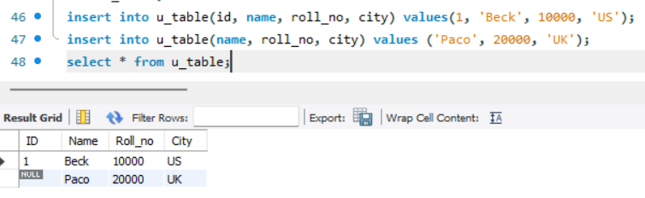

IMPORTANT POINTS –

* In one table they contain more than one unique key.
* It contains null values with duplicate null also.

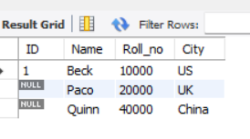

* Through Unique key we identify that record.
* If we insert duplicate data in that case we show an error.





1. PRIMARY KEY –

The PRIMARY KEY constraint uniquely identifies each record in a database table. Primary keys must contain UNIQUE values. A primary key column cannot contain NULL values. Most tables should have a primary key, and each table can have only ONE primary key.

Ex –

CREATE TABLE student (Name varchar (30), Roll_no int (5) NOT NULL PRIMARY KEY, Mobile_no int (10));

OR

CREATE TABLE student (Name varchar (30), Roll_no int (5) NOT NULL, Mobile_no int (10), PRIMARY KEY (Roll_no));

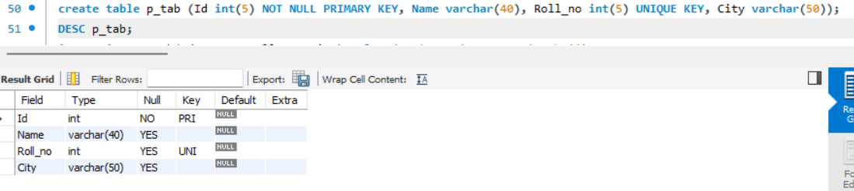

IMPORTANT POINTS –

* Primary key identifies each record uniquely.
* In one table only one primary key is allowed.
* Cannot contain NULL value.



* Must contain unique values.



* In every table there should be one primary key to identifies individual row and details.

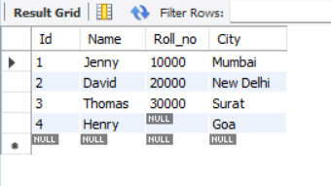

1. AUTO INCREMENT –

Auto increment is used to generate a unique number, when a new record is inserted into a table.

Syntax –

CREATE TABLE table_name (column_name int NOT NULL AUTO_INCREMENT,

Column_name1 varchar(50) NOT NULL, Column_name2 varchar(50), PRIMARY KEY (column_name));

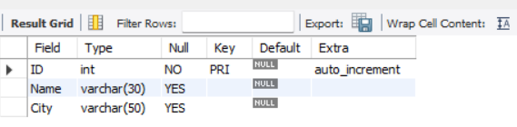

Create table a_table(ID int NOT NULL AUTO_INCREMENT PRIMARY KEY, Name varchar(30), City varchar(50));

INSERT INTO a_table(Name, City) values(‘Khushi’, ‘Dhar’);

NOTE – Not mandatory to define in insert into whose initialised auto_increment in table.

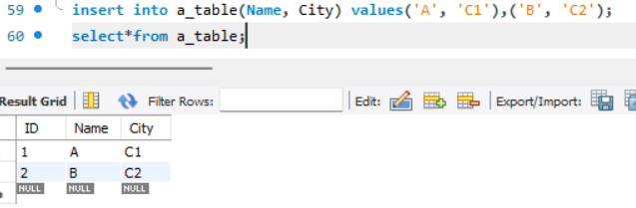

INSERT INTO a_table(ID, Name, City) values (NULL, ‘Nandini’, ‘Indore’), (NULL, ‘Sakshi’, ‘Dewas’);

NOTE – Not considered null it will only increase by 1.

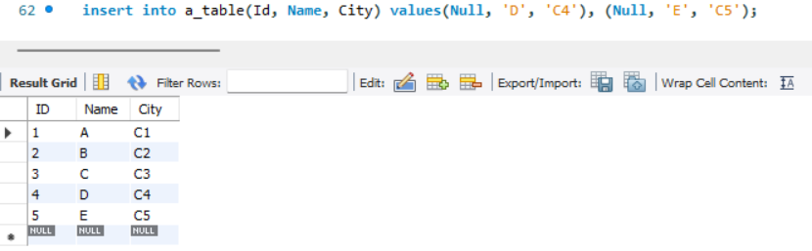

INSERT INTO a_table(ID, Name, City) values (NULL, ‘Khushi’, ‘Dhar’), (1, ‘Jaiswal’, ‘Indore’);



* For duplicate values – 
* For different values –

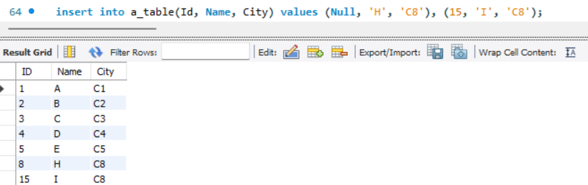

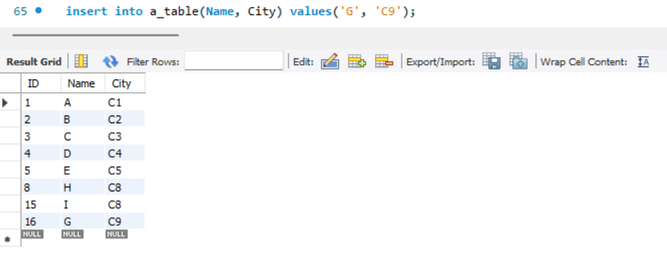

NOTE – It replace null into 1 and then next row are not considered it will omit t

Starting with particular no. –

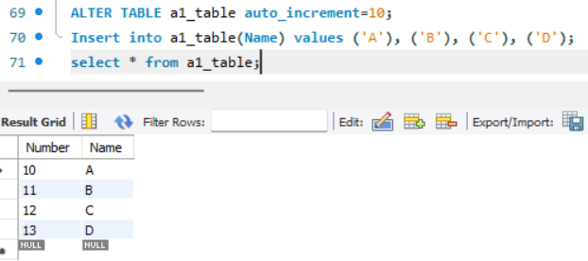

Insert the data without specifying column name –

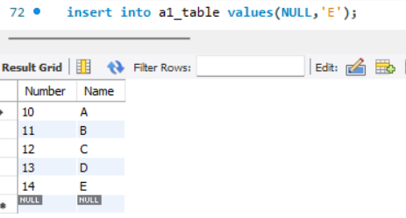

IMPORTANT POINTS –

* Increased by +1.
* In one table we use only one time auto increment column.
* Auto increment ignore null values. If we declare null value in auto increment is does not considered and increase +1.
* If we initialize the size of int (auto increment) it will increment the value between the range after the range it will not consider.

1. ALIAS –

Alias are used to temporarily rename a table name or column name.

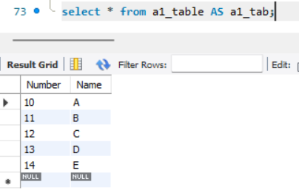

For Table –

Syntax – SELECCT column_name FROM table_name AS alias_name;

For Table –

Syntax – SELECT column_name AS alias_name FROM table_name;

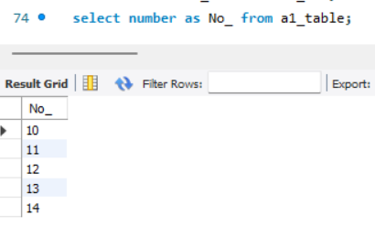

Or

Without space

SELECT column_name alias_name FROM table_name;

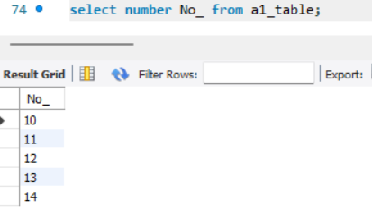

OR

With space

SELECT column_name AS “alias_name” FROM table_name;

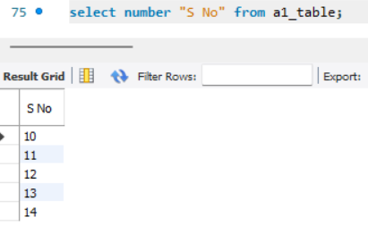

Or

SELECT column_name AS [alias_name] FROM table_name; (NOT SUPPORT IN MYSQL)

1. Foreign Key –

* A Foreign Key in one table points to a PRIMARY KEY in another table.
* A FOREIGN KEY can have different name than the primary key it comes form.
* The primary key used by an foreign key is also known as parent key. The table where the primary key is from as a parent table and another one is child table.
* The foreign key can be used to make sure that the row in one table have corresponding row in another table.
* Foreign key value call be null, even though primary key value can’t.
* Foreign key don’t have to be unique in fact, they often aren’t.

CREATE TABLE WITH FOREIGN KEY –

Syntax –

CREATE table_name( column_name constraint with primary key, column_name dtype, **CONSTRAINT** new_tname FOREIGN KEY(new_table_column_name) **REFERENCES** old_tname (that column_name);

The constraint clause allow to define constraint name for the foreign key constraint. If we omit it, MYSQL will generate a name automatically. It is optional.

The REFERENCES clause specifies the parent table and its column to which the columns in the child table refer. The number in the child table and parent table specified in the FOREIGN KEY and REFERENCES must be same.

**In table we can create more than one foreign key.**

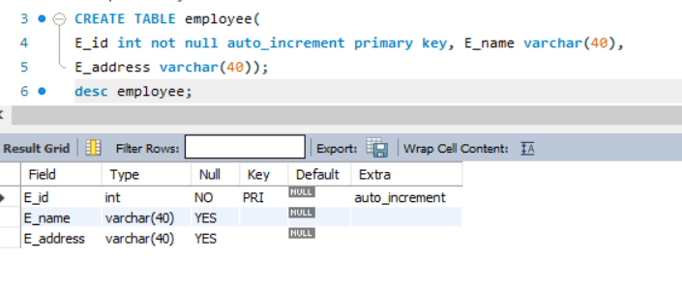

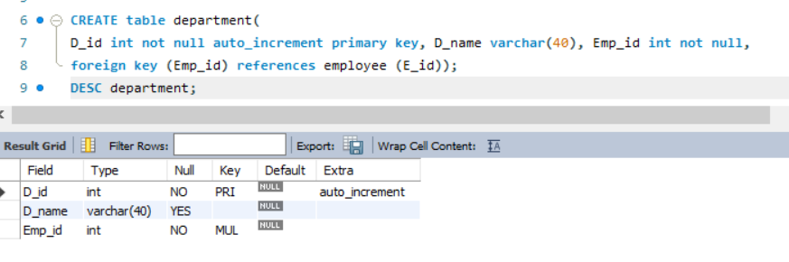

ARITHMETIC OPERATORS (* / + -) –

Syntax –

SELECT column_name, column_name OPERATOR value FROM table_name;

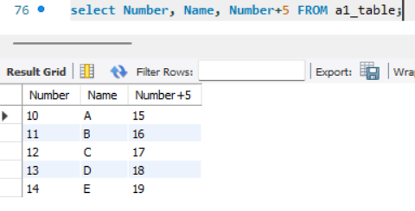

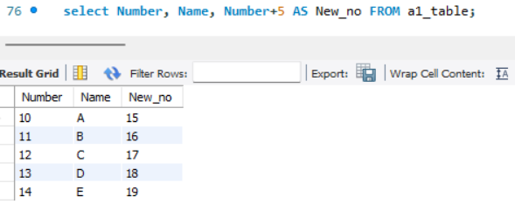

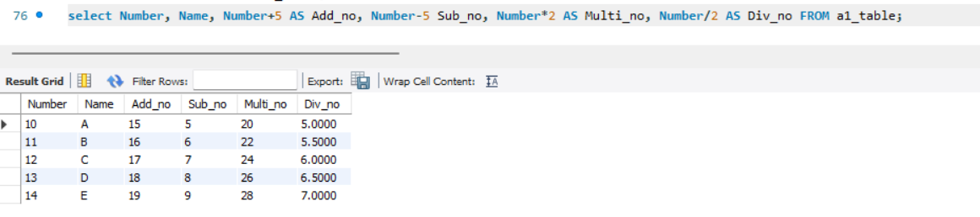

SELECT DISTINCT –

The SELECT DISTINCT statement is used to display only distinct (different) values.

Syntax –

SELECT DISTINCT column_name FROM table_name;

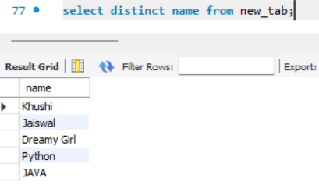

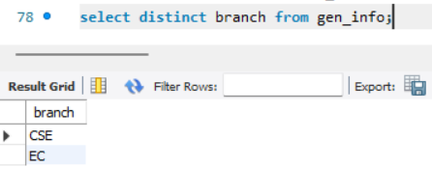

DATA DEFINITION LANGUAGE –

* Create database
* Alter database
* Drop database
* Create table
* Alter table
* Drop table
* Constraint (keys)
* Create index
* Drop index
* Create view
* Alter view
* Drop view

Alter Table –

This command is used to add/change/modify/drop existing structure of the table.

* ADD column
* Enable/Disable Constraints
* Change column
* Modify column
* Drop column

ADD column –

When anew column is to be added to the table structure without constraints.

Add Only one column at a time –

Syntax –

ALTER TABLE table_name ADD COLUMN column_name datatype (size);

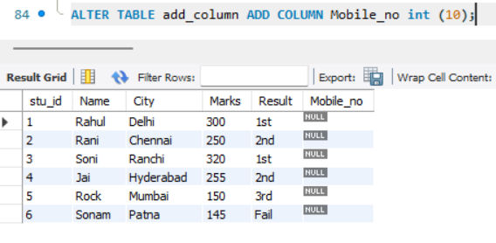

Add more than one column at a time –

Syntax –

ALTER TABLE table_name ADD COLUMN column_name datatype (size), ADD COLUMN column_name datatype (size);

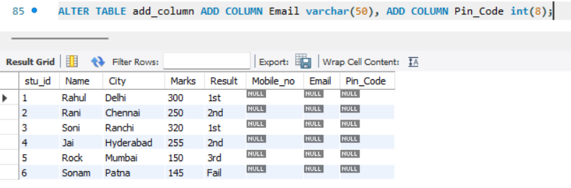

ADD COLUMN BY POSITION –

* Last (By default)
* First

Syntax –

ALTER TABLE table_name ADD column_name datatype (size) FRIST;

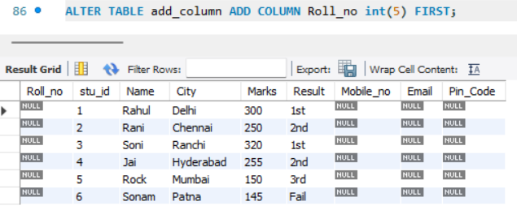

* After

Syntax –

ALTER TABLE table_name ADD COLUMN column _nmae datatype (size) AFTER column_name;

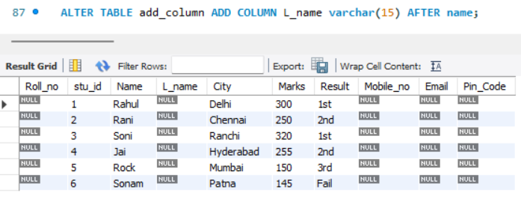

ADD COLUMN –

When a new column is to be added to the table structure with constraints.

Syntax –

ALTER TABLE table_name ADD COLUMN column_name data_type (size) Constraint_name, ADD constraint_name (column_name);





NOTE –

In above it shows a error of duplicate entry because we define the column constraints as NOT NULL with PRIMARY KEY. As we know that the primary key must hold unique value but when we define NOT NULL in column that should be add 0 in row.

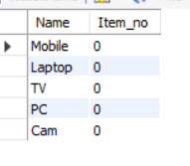

Because of that problem error will come.

To solve this problem we use AUTO_INCREMENT constraint

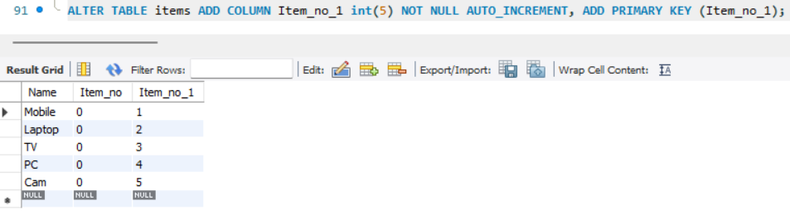

Adding Column by position with constraints –

* Last (By default)
* First

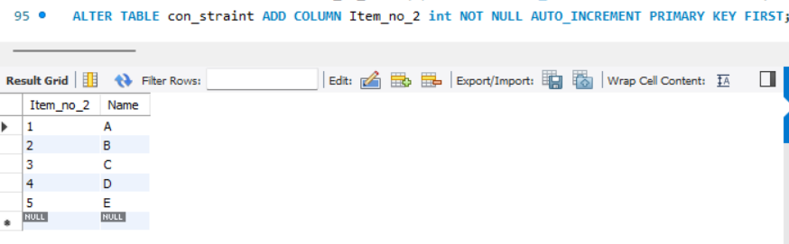

* After

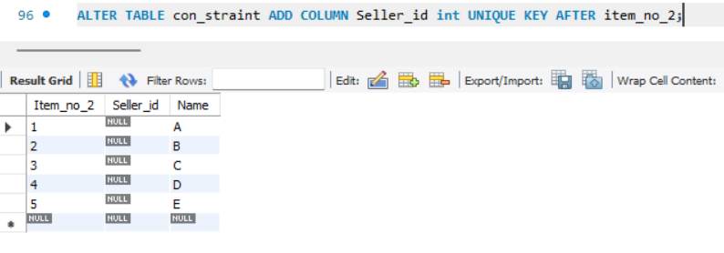

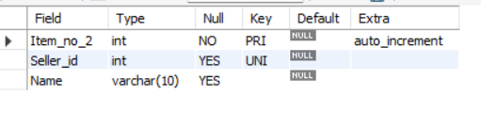

When integrity constraints have to be included –

When we make table in that table one column are duplicate or duplicate record are there to remove duplicates, we convert that column into unique key.

Syntax –

ALTER TABLE table_name ADD CONSTRAINT constraint_name column_name;

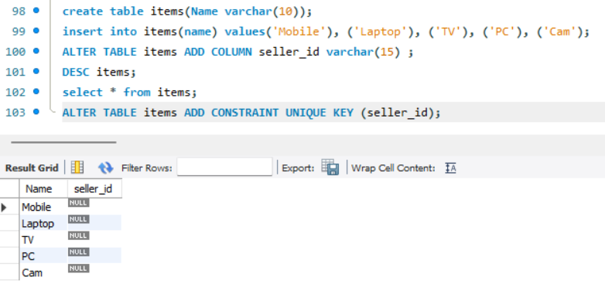

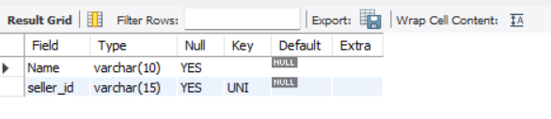

Change column name and its data type without constraints –

**Change column** –

This is used to change name and data types of an existing column.

Without constraints –

Syntax –

ALTER TABLE table_name CHANGE COLUMN old_column_name new_column_name new_data_type(size);

BEFORE -





AFTER -

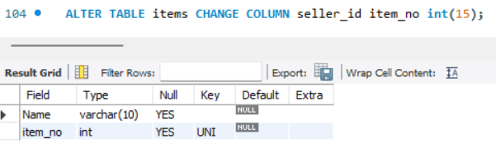

NOTE –

We cannot change name without datatype and size. It is mandatory to give name datatype and size.

Change more than one column Name and its data type

Without constraints –

ALTER TABLE table_name CHANGE COLUMN old_column_name new_column_name new_data_type(size), CHANGE COLUMN old_column_name new_column_name new_data_type(size );

BEFORE –



After –

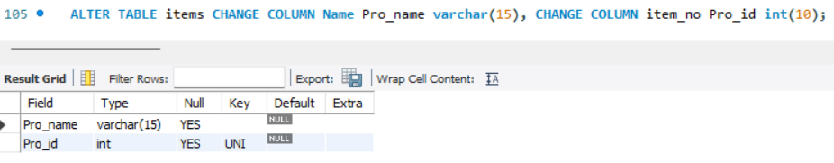

With Constraints –

Syntax –

ALTER TABLE table_name CHANGE COLUMN old_column_name new_column_name new_data_type (size) constraint_name, ADD constraints_name(column_name);

Before –



AFTER –

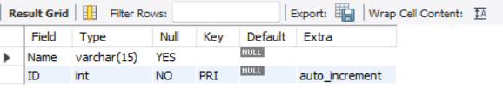

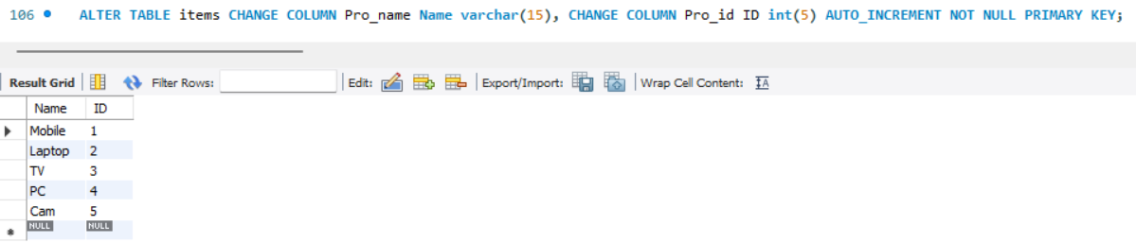

Modify Column Data types and its size –

Without Constraints –

This is used to modify size of the data type or the data type itself of an existing column without changing name.

Syntax –

ALTER TABLE table_name MODIFY COLUMN column_name data_type(size);

Before –



After –

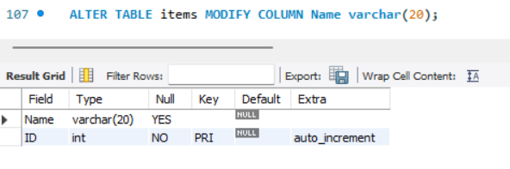

With Constraint –

Syntax –

ALTER TABLE table_name MODIFY COLUMN column_name new_data_type(size), ADD constraint_name (column_name);

Before –



After –

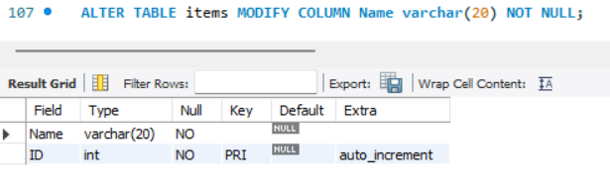

Drop column –

When a column in a table need to delete.

NOTE –

Most of the RDBMS software are not allowed to delete column.

With constraints –

Syntax –

ALTER TABLE table_name DROP COLUMN column_name;

Before –



After –



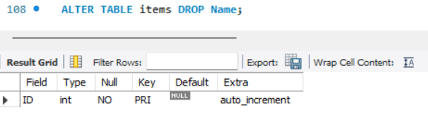

When removing constraints from a column –

Syntax –

ALTER TABLE table_name DROP constraint_name column_name;





We cannot direct delete the constraints of that column.

From this we use INDEX keyword to help the remove constraint of that column.

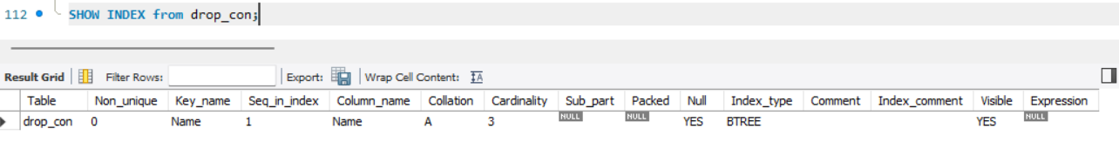

Before –

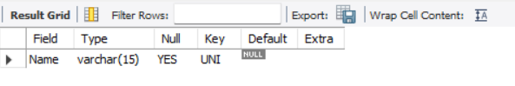

After –

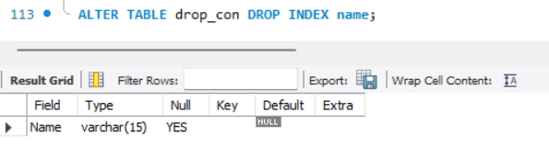

UNIQUE KEYS is deleted.

We cannot delete primary key for this method. For this some conditions are there.

Drop table or Delete Table from Database –

This command is used to delete/remove table from the database.

Syntax –

DROP TABLE table_name;

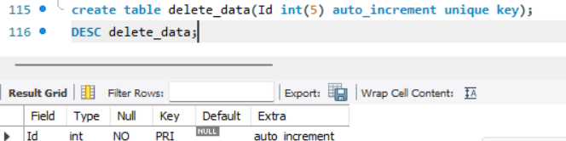

Before –

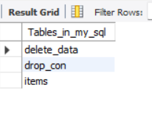

After –

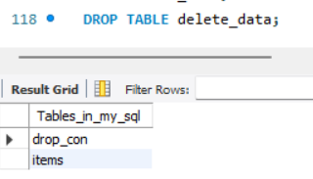

Delete Data of table using TRUNCATE TABLE –

When we only want to delete the data inside the table, and not the table itself.

Syntax –

TRUNCATE TABLE table_name;

Before –

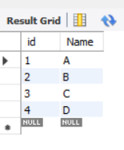

After –

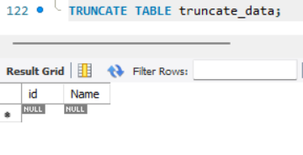

Rename Table –

This command is used to rename one or more table.

Syntax –

RENAME TABLE old_table_name to new_table_name;

Before –

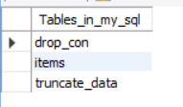

After –

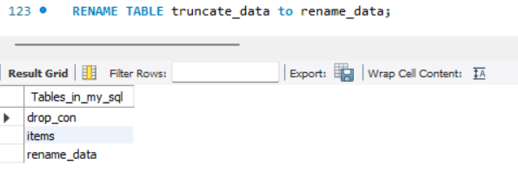

ALTER DATABASE –

ALTER DATABASE enables you to change the overall characteristics of a database. These characteristics are stored in dp.opt file in the database directory. To use ALTER DATABSE, you need the ALTER privilege on the database.

ALTER SCHEMAS is a synonym for ALTER DATABSE.

The database name can be omitted from the syntax, in which case the statement applies to the default database.

Syntax –

ALTER DATABASE database_name;

DROP DATABASE –

The DROP DATABASE statement is used to delete a database.

Syntax –

DROP DATABASE database_name;

Show columns –

It shows all the column of table and their data type along with any other specific details. It just like DESC table_name.

Syntax –

SHOW COLUMNS from table_name;

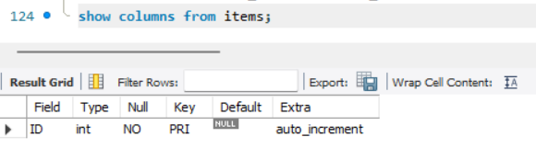

Show create database –

It shows commands which you have written while creating your database.

Syntax –

SHOW CREATE DATABASE database_name;

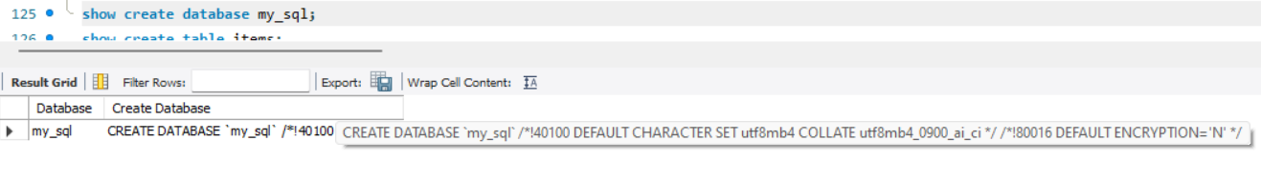

Show create table –

It shows commands which you have written while creating table.

Syntax –

SHOW CREATE TABLE table_name;

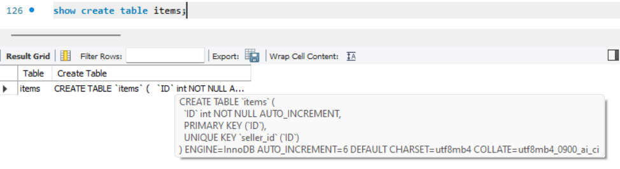

UPDATE –

The update statement is used to update existing records in a table.

Syntax –

UPDATE table_name SET column1 = value1, column2 = value2,….WHERE some_column = some_value;

NOTE –

WHERE is necessary otherwise all records will be replace with given value.

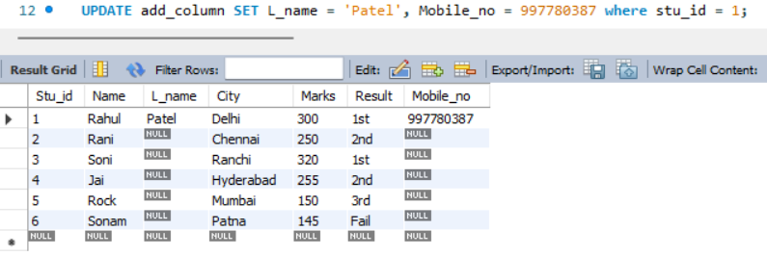

If we don’t use where clause at that time it changes whole column from table.

Before –

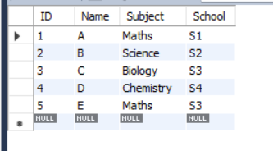

After –

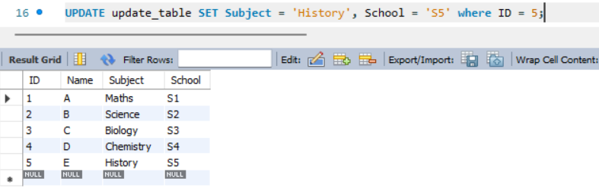

Update with Case (How to update more than one record in row) –

Syntax –

UPDATE table_name SET new_column =

CASE

when column_name1 = some_value1 THEN new_value1

when column_name2 = some_value2 THEN new_value2

ELSE new_value3

END;

NOTE –

It works in only one column we cannot change more than one column at a time.

Before –

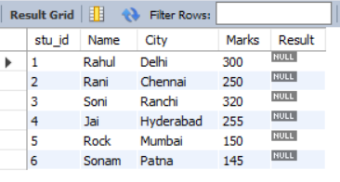

After –

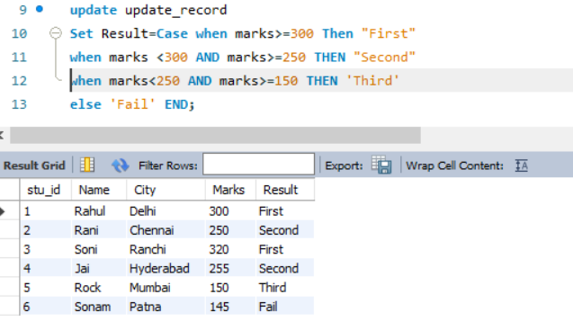

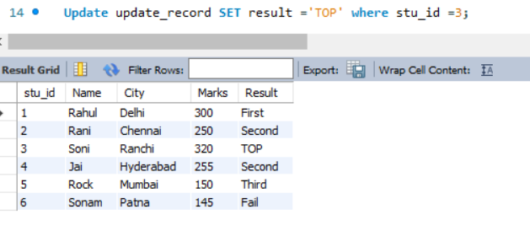

DELETE –

The Delete statement is used to delete records in a table.

1. Delete a specific record –

Syntax –

DELETE FROM table_name WHERE some_column =some_value;

NOTE – WHERE is necessary otherwise all records will be delete.

Before –

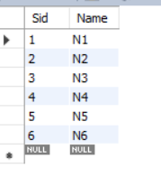

After –

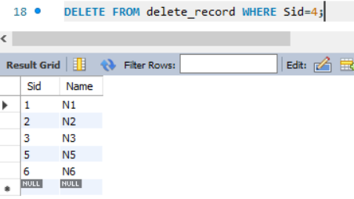

1. Delete All records –

Syntax –

DELETE FROM table_name;

Or

DELETE * FROM table_name

Note – We cannot undo this.

Before –

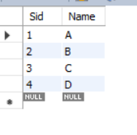

After –

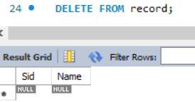

Copy old table to new table –

1. With Same Database –

Syntax –

CREATE TABLE new_table LIKE old_table;

INSERT new_table SELECT *FROM old_table;

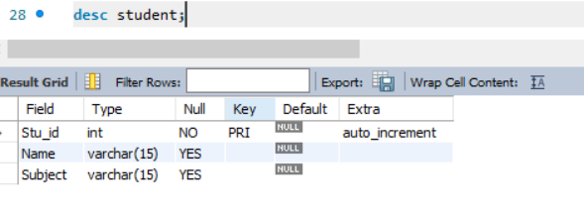

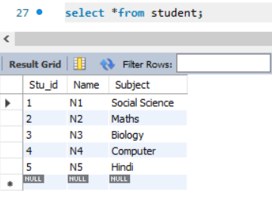

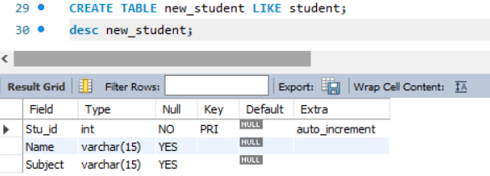

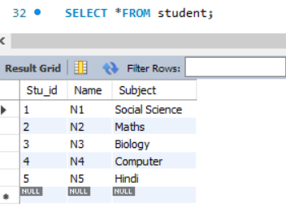

1. Within different databases –

Use the database where you want to copy the old table.

Syntax –

CREATE TABLE new_table LIKE old_db.old_table;

INSERT new_table SELECT * FROM old_db.old_table;

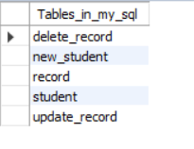

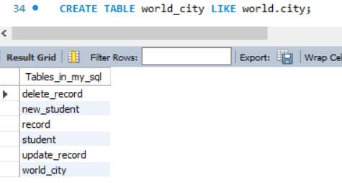

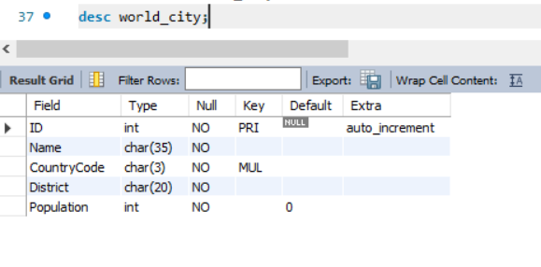

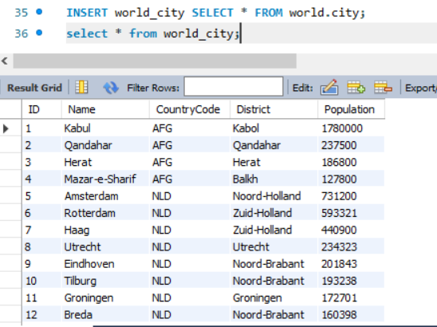

FUNCTIONS –

1. MIN(column_name) – Smallest value of the selected column.

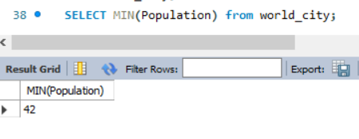

1. MAX(column_name) – Largest value of the selected column.

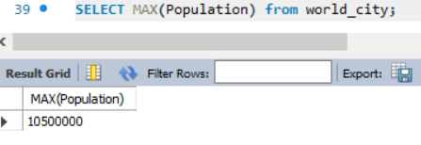

1. SUM(column_name) – The total sum of a numeric column.

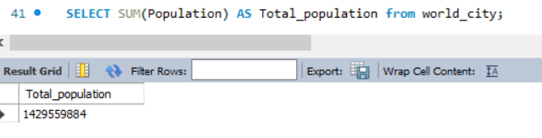

1. AVG(column_name) – The average value of a numeric column.

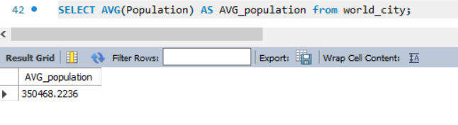

1. SQRT(column_name) – The square root of a numeric column.

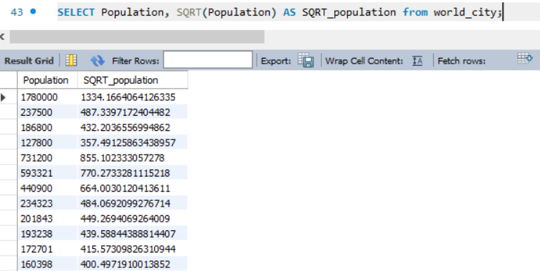

DECIMAL (Data Types) –

1. Syntax- Column_name DECIMAL (T, D)

Where,

T = Total digits (1 – 65 Range)

D = Digits after decimal (Range 0 – 30) and must not be more than T.

Example –

Price Decimal (7, 2) – 45836.25

Instead of Decimal we write DEC, NUMERIC, FIXED.

1. Column_ name DECIMAL(T)

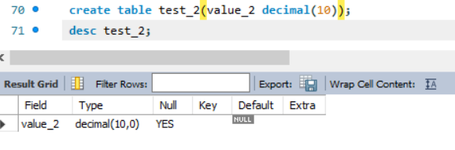

1. Column_name DECIMAL(T, 0)
2. Column_name DECIMAL; (Default T = 10)

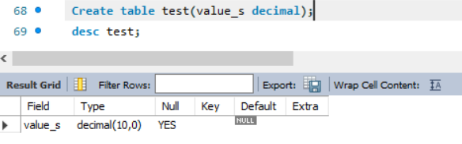

SIZE –

|  |  |
| --- | --- |
| No. of Digits | Number of Bytes |
| 0 | 0 |
| 1 – 2 | 1 |
| 3 – 4 | 2 |
| 5 – 6 | 3 |
| 7 – 9 | 4 |

Example –

187523.25 – 5 + 1 = 6 Bytes

14456666998877.325 – 4 + 3+ 2 = 9 Bytes

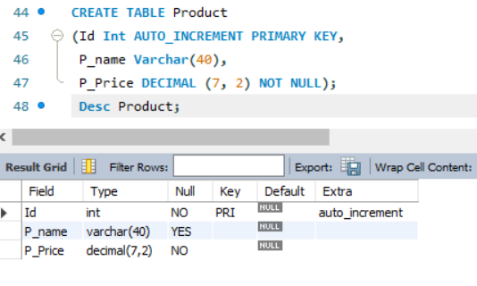

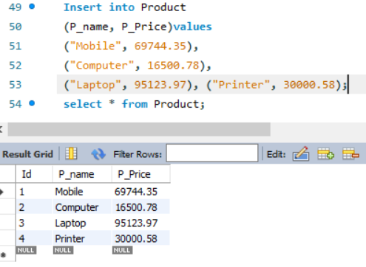

1. ZEROFILL –

Ex – Cost DECIMAL (10, 4) = 895.65 🡪 000895.6500

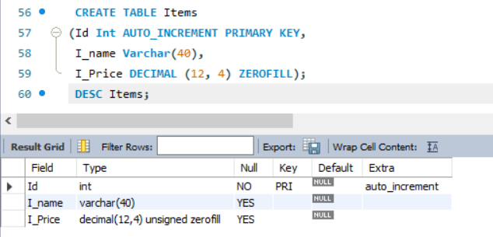

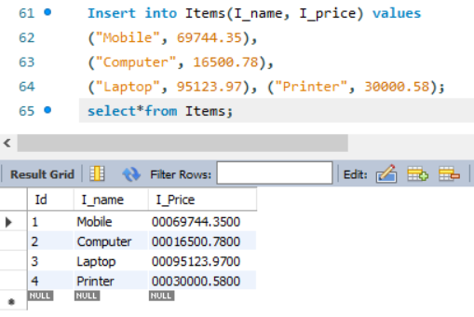

1. ROUND (column_name) – Function is used to round a numeric field to the number of decimals specified.

Before –

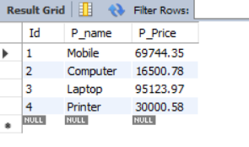

After –

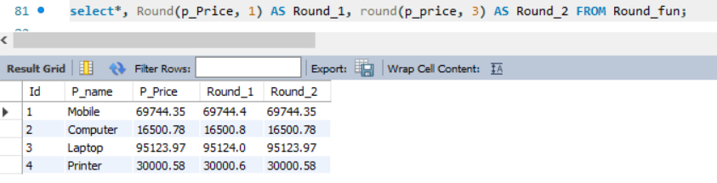

1. COUNT() –

The COUNT(column_name) function returns the number of values(Null values will not be counted) of the specified column.

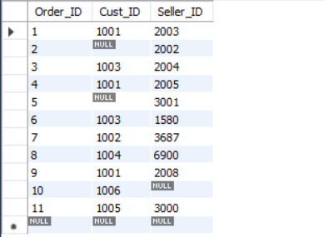

Syntax –

SELECT COUNT (column_name) FROM table_name;

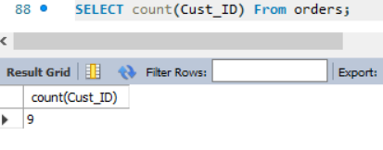

COUNT(*) function returns the number of record in the table.

Syntax –

SELECT COUNT(*) FROM table_name;

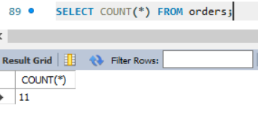

The COUNT (DISTINCT column_name) function returns the number of distinct values (different value) of the specified column.

SELECT COUNT (DISTINCT column_name) FROM table_name;

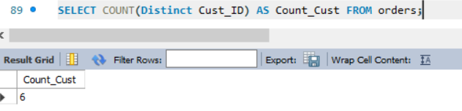

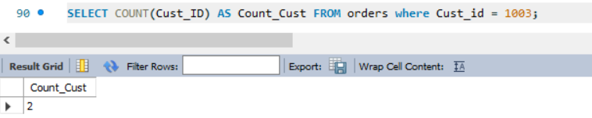

1. UPPER (column_name) or UCASE(column_name) – Converts the value of a field to uppercase.

Before –

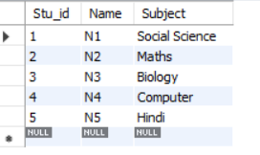

After –

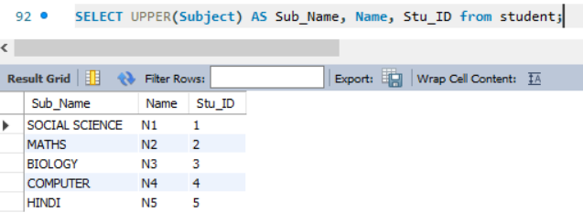

1. LOWER(column_name) or LCASE(column_name) – Converts the value of a field to lowercase.

Before –



After –

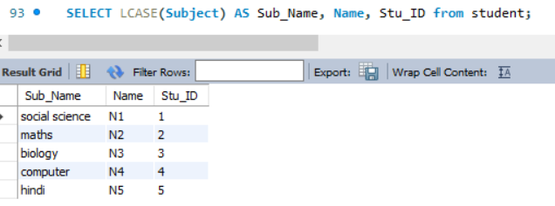

1. MID(column_name, start, length) or SUBSTRING(column_name, start, length) – Function is used to extract characters from a text field.

Before –



After –

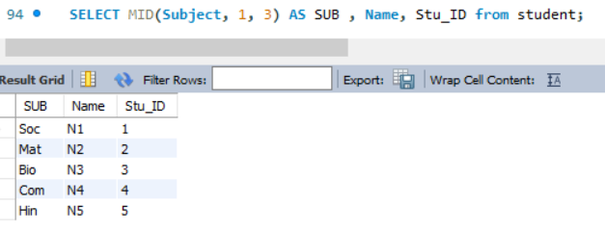

1. LENGTH(column_name) – The length of the value in a text field (in bytes).

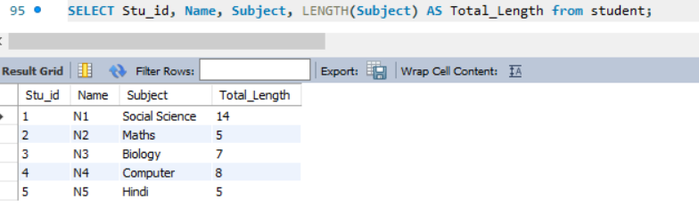

NOTE – It count space also.

1. CONCAT(column_name1, column_name2, ….) – It joints two or more column.

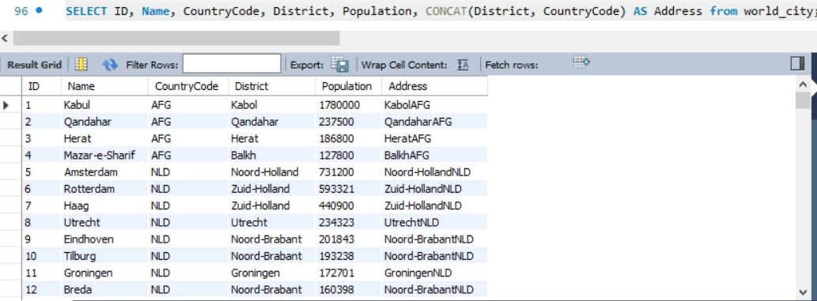

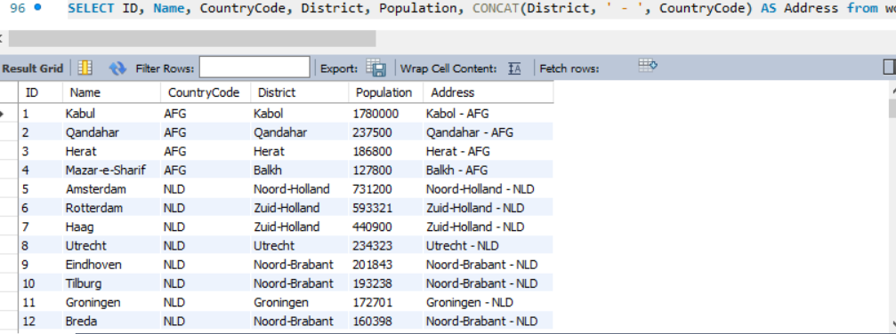

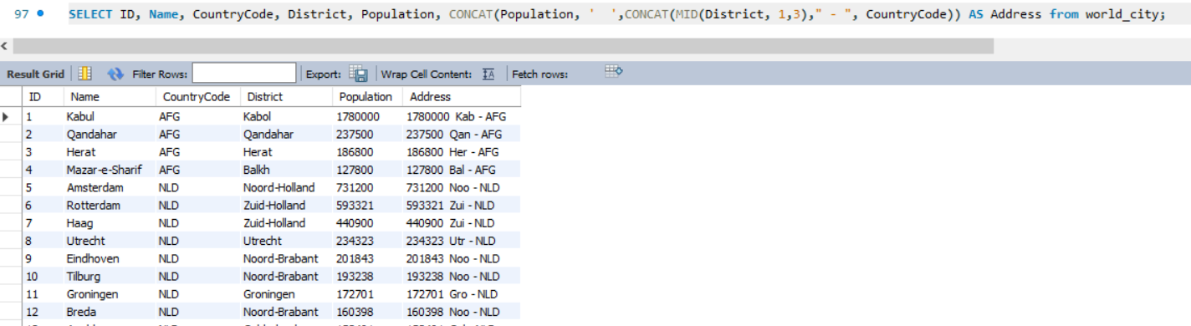

1. CONCAT_WS() –

This function adds two or more expression together with a separator.

Syntax –

CONCAT_WS(separator, expression1, expression2, expression3, ….)

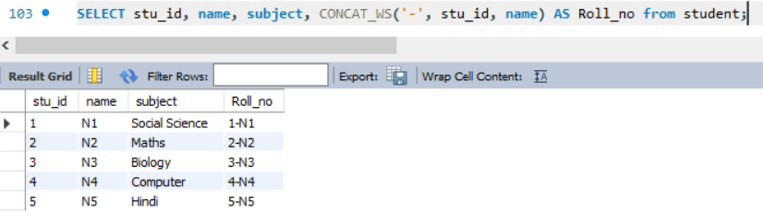

1. REVERSE(column_name) – It reverse the order of letter in string.

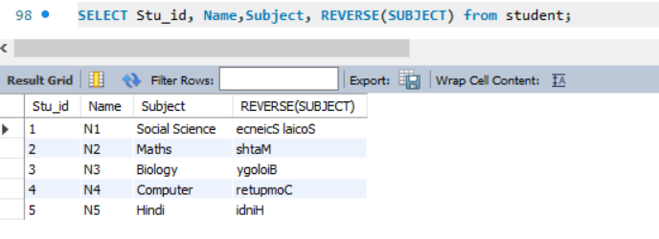

1. NOW() – Function returns the current system date and time.

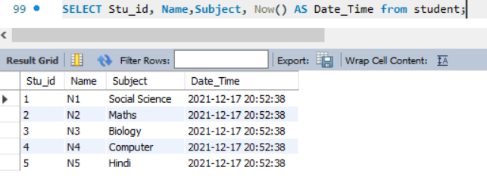

1. FORMAT(column_name, format_type) – Function is used to format how a field to be displayed.
2. ASCII(column_name) – Function returns the ASCII value of the first character in a row.

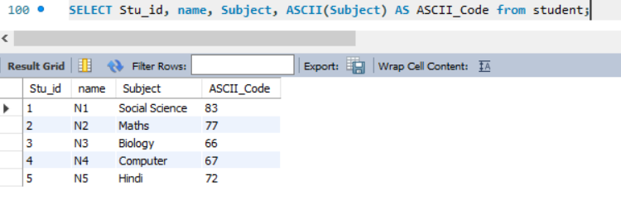

1. CHAR_LENGTH(column_name) or CHARACTER_LENGTH(column_name) – Returns the length of a string (in characters).

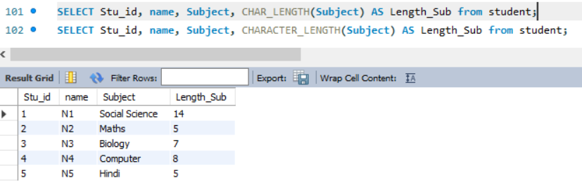

1. FIELD () –

This function returns the index position of a value in a list of values.

This function performs a case- insensitive search.

Syntax –

FIELD (value_to_search, value1, value2, value3, ….);

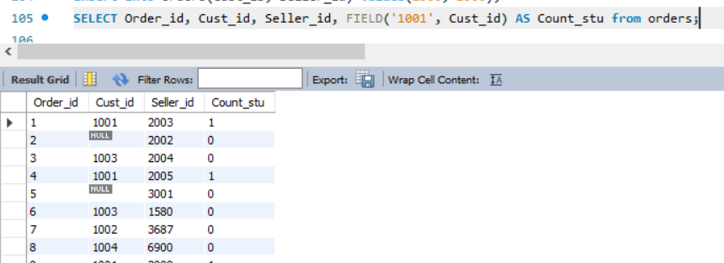

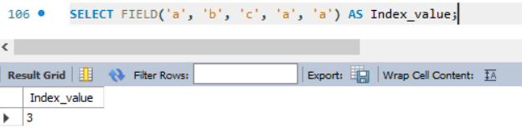

NOTE – If the specified value is not found in the list of values, the function will return 0. If value is Null, the function will return 0.

1. FIND_IN_SET() –

Returns the position of a string within a list of strings.

Syntax –

FIND_IN_SET(string_to_search, string_list);

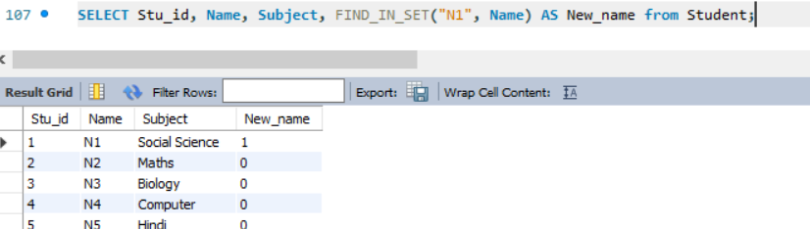

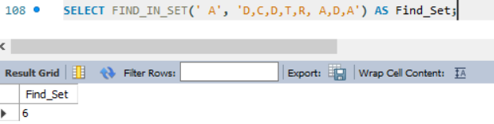

NOTE –

* If string is not found in string_list, this function returns 0.
* If string or string_list is NULL, this function returns NULL.
* If string_list is an empty string (““), this function returns 0.
* It case sensitive. Count space also.

Group By –

The group by statement groups rows that have the same values into summary rows.

Ex – “find the number of customers in each country”.

The GROUP BY statement is often used with aggregate function (COUNT(), MAX(), MIN(), SUM(), AVG() ) to group the result – set by one or more columns.

Syntax –

SELECT function(column_name) from table_name GROUP BY column_name;

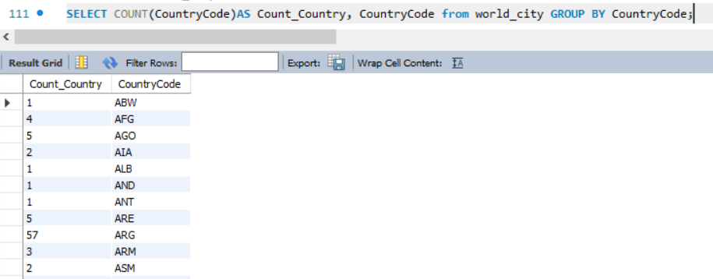

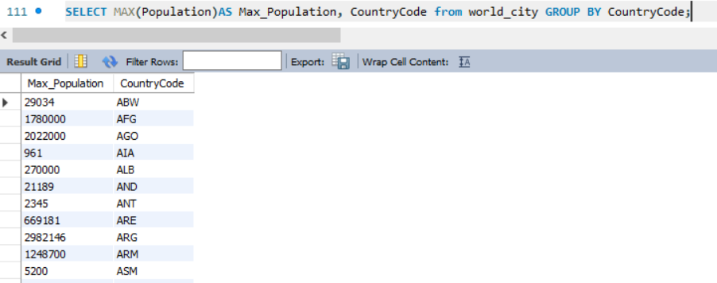

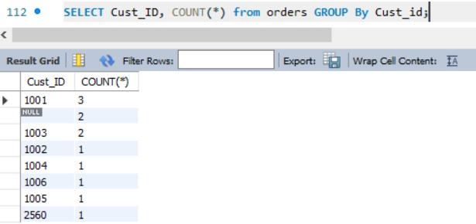

HAVING Clause –

The HAVING clause was added to SQL because the WHERE keyword cannot be used with aggregate functions.

Syntax –

SELECT function(column_name) from table_name GROUP BY column_name HAVING condition;

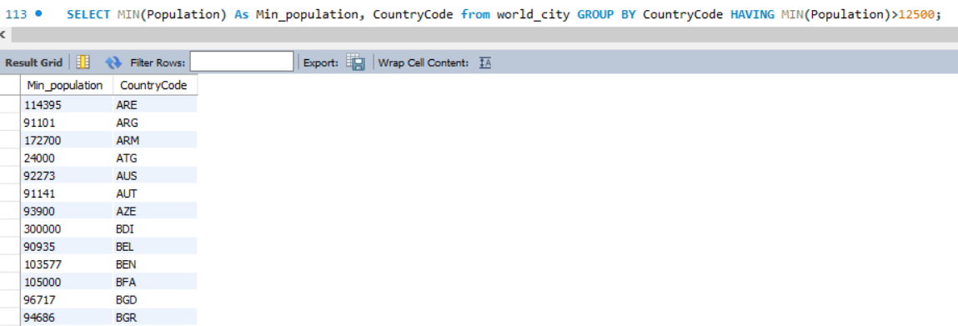

How to find Constraint Name –

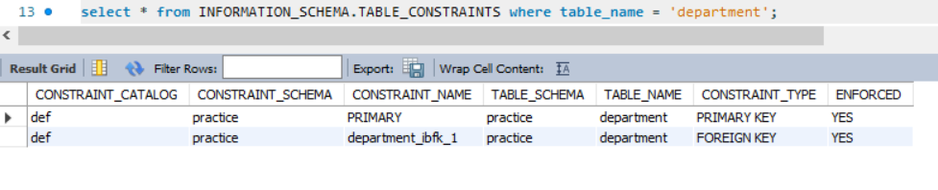

INFORMATION_SCHEMA.TABLE_CONSTRAINTS already define in mysql.

DROP FOREIGN KEY FROM TABLE –

Before –



After –

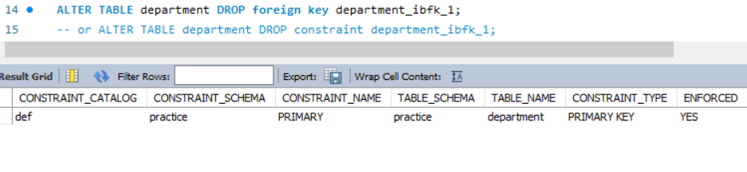

ADD FOREIGN KEY CONSTRAINT IN A TABLE –

Before –



After –

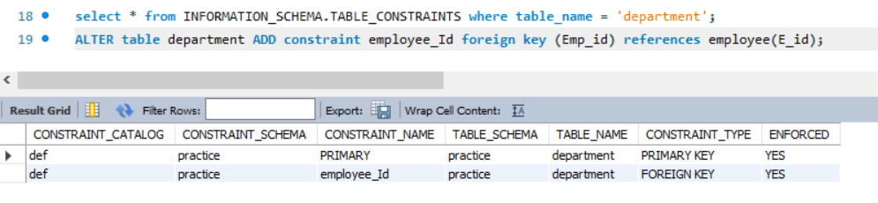

ADD COLUMN USING ALTER COMMAND –

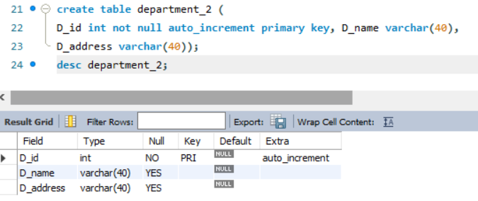

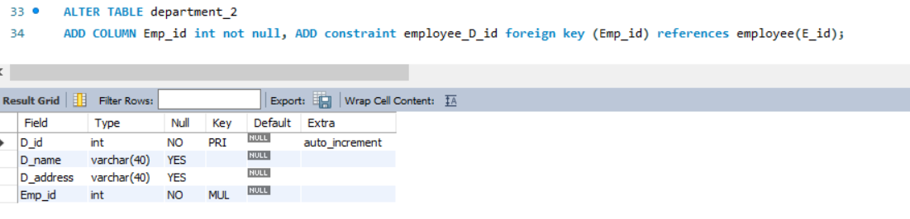

If we want to delete parent table. We cannot delete parent table until we delete child table.



Parent table delete record –

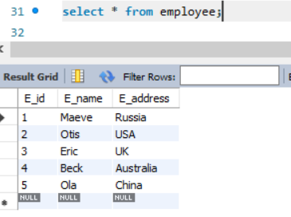

**We cannot delete data until we delete child table record.**





Before –

Parent Table –



Child table –

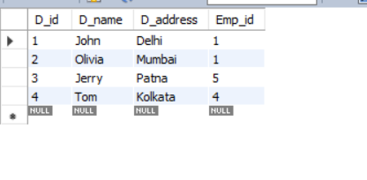

After –

Child table –

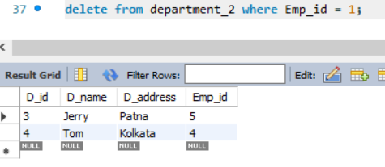

Parent table –

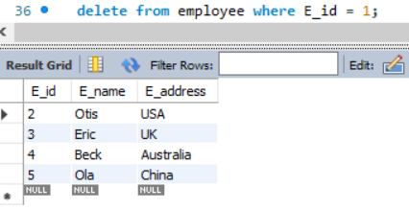

**The data will be deleted successfully.**

ON DELETE CLAUSE –

* ON DELETE CASCADE.
* ON DELETE SET NULL
* ON DELETE NO ACTION
* ON DELETE RESTRICT

ON DELETE CASCADE –

ON DELETE CASCADE constraint is used in MySQL to delete the rows from the child table automatically, when the rows from the parent table are deleted.

Syntax –

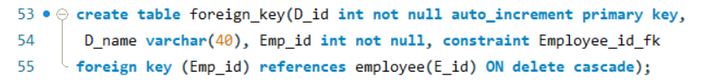

Parent table –

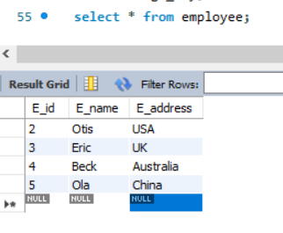

Child table –

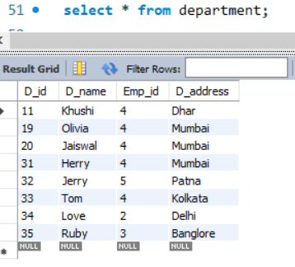

After deleting –

Parent table –

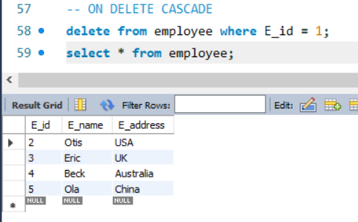

Child table –

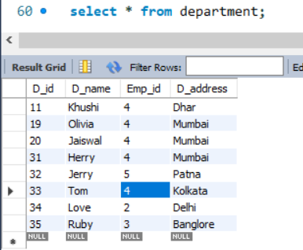

ON DELETE SET NULL –

A foreign key with "set null on delete" means that if a record in the parent table is deleted, then the corresponding records in the child table will have the foreign key fields set to NULL. The records in the child table will **not** be deleted in SQL Server.

Syntax –

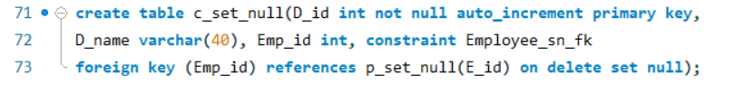

Parent table –

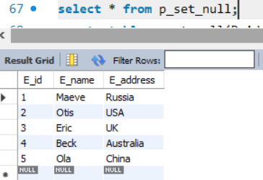

Child table –

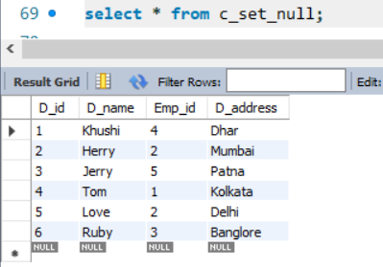

After –

Parent table –

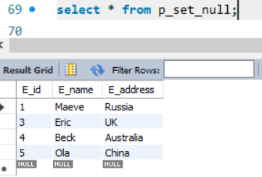

Child table –

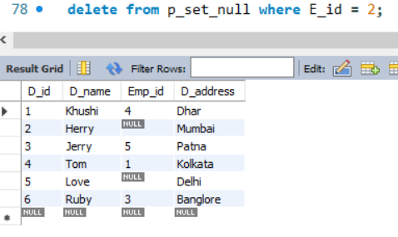

ON DELETE NO ACTION or ON DELETE RESTRICT–

Syntax –



Before –

Parent table –

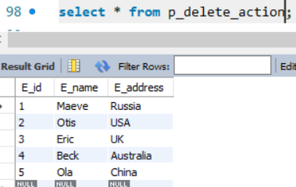

Child table –

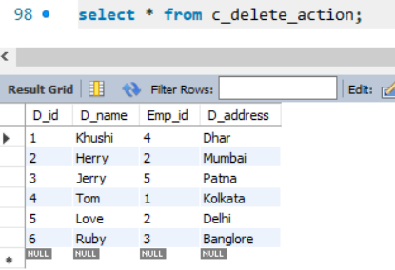

After –

Child table –

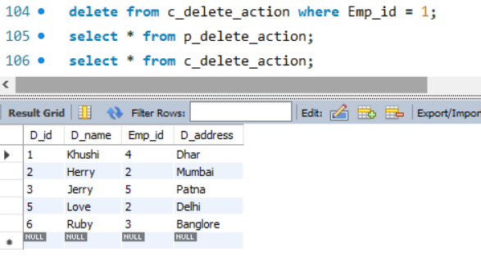

Parent table –

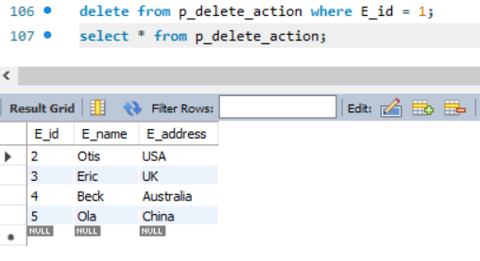

**It is just like default. In this function we 1st we delete the child table record then parent table.**

**COMPOSITE KEY** –

Combination of two column to make primary key is known as composite key.

A composite key is the [DBMS key](https://www.javatpoint.com/dbms-keys) having two or more attributes that together can uniquely identify a tuple in a table. Such a key is also known as **Compound Key.**

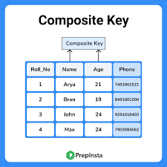

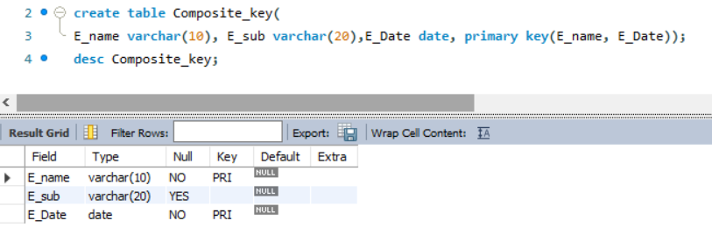

Generally, we avoid composite key because they create complication in searching, identification etc.

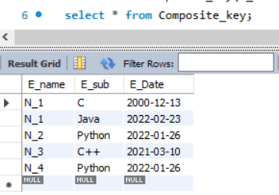

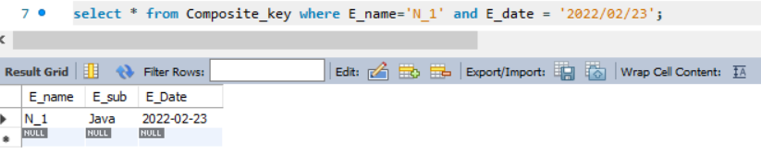

Shorthand Notation –

Suppose we have two table and in that tables, there are one common column name Rollno. And we retrieve that both column in sql.

Generally, we use select* from table_1, table_2;

But this are not working because RDBMS are unable to understand which column I retrieve. So, for this we use syntax like table_1.column_name.

Shorthand is used to identify which column belongs to which table and for which column data we want to retrieve.

How to join tables –

Join means make relational between tables. To make relation we need primary key and foreign key.

1. CROSS (JOIN/ PRODUCT) / CARTESIAN (JOIN/ PRODUCT) –

The cross join returns every row one table crossed with every row from the second.

The CROSS-JOIN keyword returns all records from both tables (table1 and table2).

The CROSS JOIN keyword returns all matching records from both tables whether the other table matches or not.

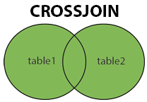

Syntax –

SELECT * FROM Table_1 CROSS JOIN Table_2;

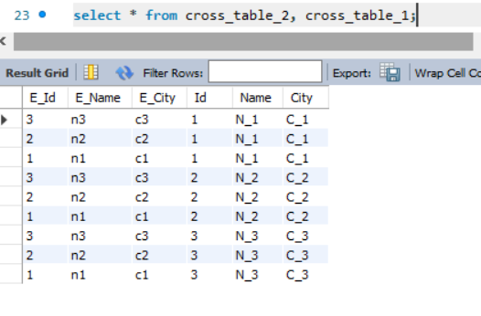

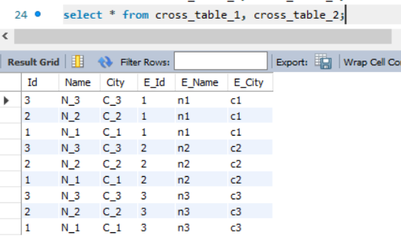

SELECT Column_name_1, Column_name_2 FROM Table_1 CROSS JOIN Table_2;

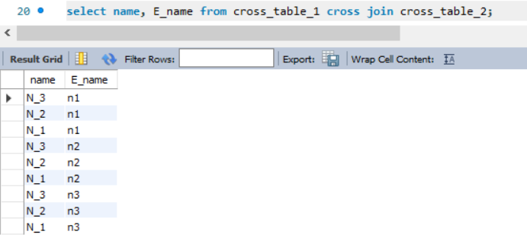

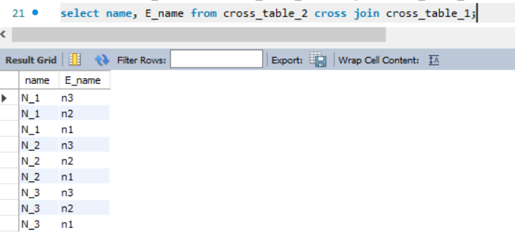

SELECT * FROM Table_1, Table_2;

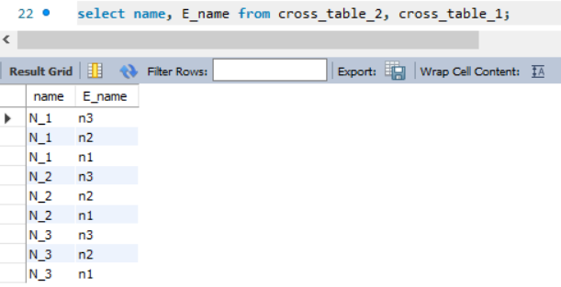

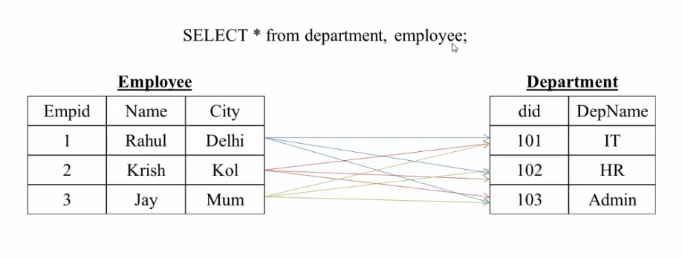

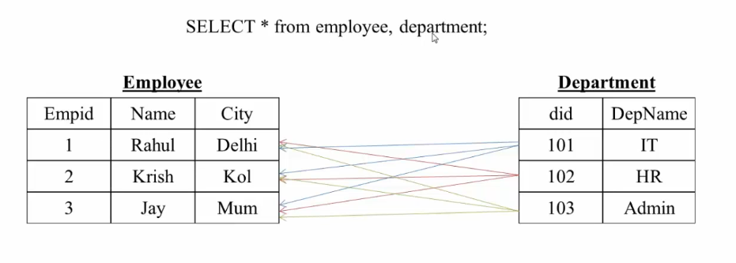

When table_1 > table_2 that time

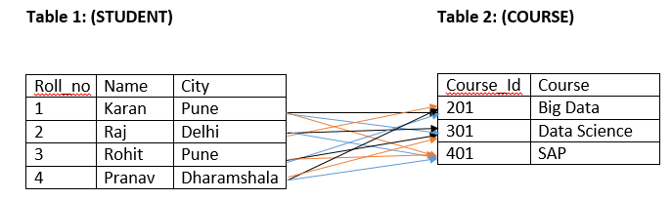

When table_1 < table_2 that time

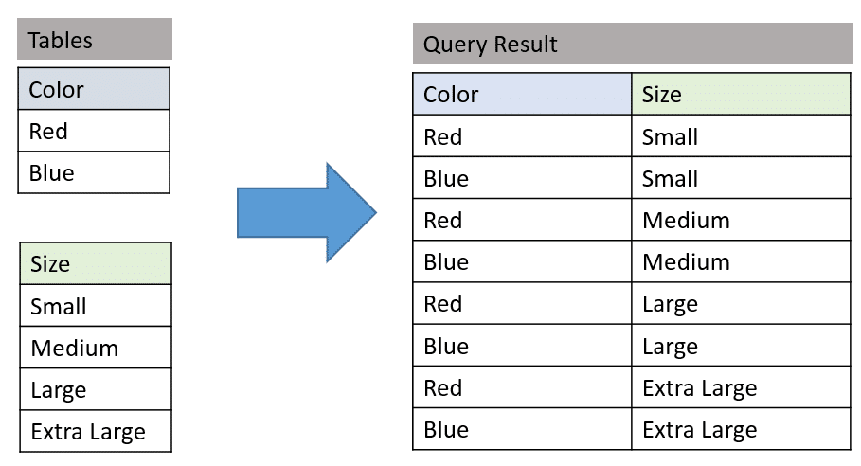

DEPENDS ON RDBMS.

In general we cannot use cross join because might be possible our system may be hang or performance of that system may be low.

INNER JOIN –

An INNER JOIN is ass CROSS JOIN with some results rows removed by a condition in the query.

INNER JOIN keyword selects records that have matching values in both tables.

* EQUIJOIN –

It creates a join for equality or matching columns values of the relative tables. EQUI JOIN also create JOIN by using JOIN with ON and then providing the names of the columns with their relative tables to check equality using equal sign(=).

SELECT column_name FROM table_1 INNER JOIN table_2 ON (table_1)column_name_1 = (table_2)column_name_2;

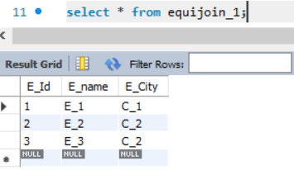

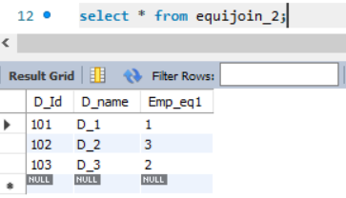

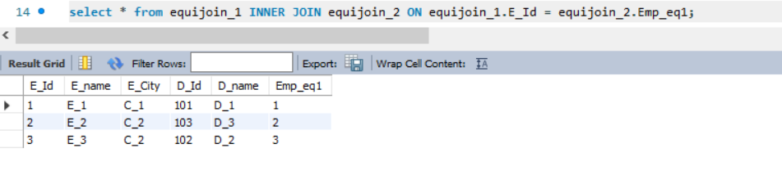

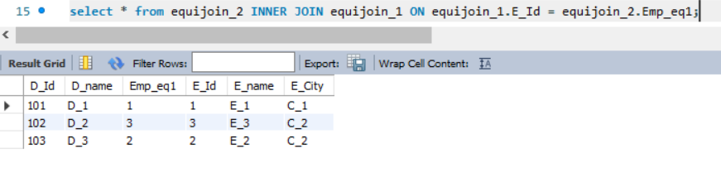

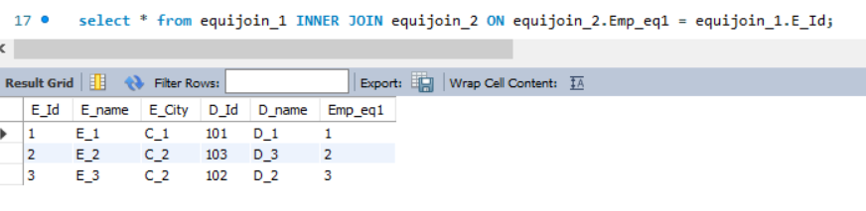

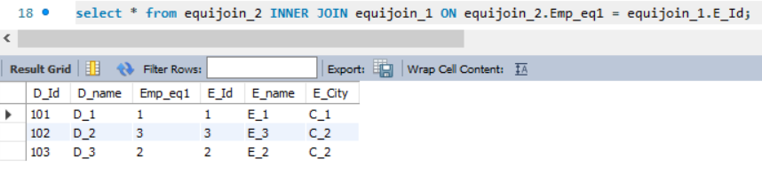

* NON – EQUIJOIN –

It performs a JOIN using comparison operator other than equal (=) sign like >, <, >=, <=, <> with condition.

SELECT column_name FROM table_1 INNER JOIN table_2 ON (table_1)column_name <> (table_2)column_name;

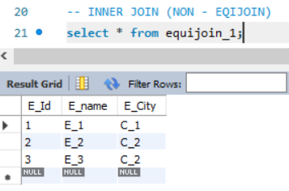

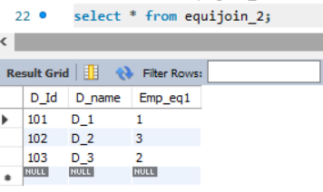

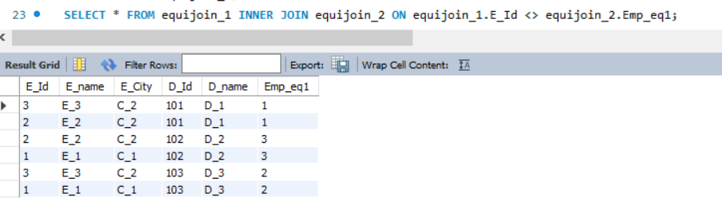

NATURAL JOIN –

SELECT column_name FROM table_1 NATURAL JOIN table_2;

In both table the name of column must be same.

OUTER JOIN –

An outer join returns all rows from one of tables, along with matching information from another table.

* Left outer join/ Left join
* Right outer join/ Right join
* Full outer join/ Full join (it is not work in mysql)

LEFT OUTER JOIN –

The left join keyword returns all rows from the left table, with the matching rows in the right table. The result in NULL in the right side when there is no match.

In a LEFT OUTER JOIN the table comes before is the left table, and the table that comes after the join is the right table.

